Entrepreneurship Education Bursaries
4th Call – November 2023

CALL FOR ENTREPRENEURSHIP EDUCATION BURSARY APPLICATIONS

The 4th call for the GROWTHhub Entrepreneurship Education Bursary welcomes bursary projects that support the development of entrepreneurial mindsets for students across all TU Dublin programmes and levels of study, from apprenticeship to PhD. This call document sets out the following:

- Background information on the GROWTHhub project, including its mission and objectives.
- Objectives of GROWTHhub Entrepreneurship Education Bursaries
- Bursary conditions
- Application requirements and evaluation process

Introduction to GROWTHhub Project

GROWTHhub is a Higher Education Authority Human Capital Initiative Pillar 3 collaborative project involving Technological University Dublin and South East Technological University.

At TU Dublin, the GROWTHhub project mission is to encourage growth and entrepreneurial mindsets among our students. Core beliefs supporting this mission are: (i) entrepreneurship is an opportunity and growth-based mindset; (ii) innovation as a constituent of entrepreneurship is central to value creation, delivery and capture at the level of the organisation and the nation; and (iii) diversity of thought is a positive educational and societal objective.

In the context of these beliefs, GROWTHhub defines entrepreneurship as a transversal competence, which applies to all spheres of the lives of our community of learners: from nurturing personal development, to actively participating in society, to innovating as an employee, and also to starting up ventures (cultural, social or commercial). This broad definition of entrepreneurship hinges on the creation of cultural, social or economic value. It thus embraces different types of entrepreneurship, including intrapreneurship, social entrepreneurship, green entrepreneurship and digital entrepreneurship. It applies to individuals and groups (teams or organisations) and it refers to value creation in the private, public and third sectors and in any hybrid combination of the three. Lastly, it is domain neutral: one can act upon ideas and opportunities to generate value for others in any domain and possible value chain.

Find more information at: www.tudublin.ie/growthhub

Objectives of the GROWTHhub Entrepreneurship Education Bursary

In pursuit of the overall GROWTHhub mission the GROWTHhub Entrepreneurship Education Bursaries support the design and development of pedagogical resources, from any discipline, that supports the different stages of student entrepreneurial learning and development pathways, including:

- Creating enterprise awareness (and moving to interest through engagement with entrepreneurial role models, competitions and events);
- Developing the learner’s entrepreneurial mindset (including ambition, motivation, personal confidence, resilience, and tolerance of uncertainty/risk);
- Developing the learner’s entrepreneurial capabilities (including creativity, opportunity recognition, decision-making by critical analysis, interpersonal skills, and implementation of ideas by leadership);
- Reinforcing entrepreneurial effectiveness attributes (including independent self-direction, appreciate and create multiple forms of value, and implement enterprising ideas).

Areas in which bursary applications are sought include:

- Initiatives that seek to develop entrepreneurial mindsets and skills. Such initiatives should foster transversal skills aimed at strengthening the knowledge, skills and motivation to engage in entrepreneurial activities in a variety of settings; and opening up new learning opportunities through the practical application of entrepreneurial skills.

As examples, proposed initiatives in this area might include (but are not limited to):
- Practical pedagogies illuminating the entrepreneurial process. For example, a structure or process for lecturers to bring people into the notion of the entrepreneurial mind-set in different disciplines.
- Development of cross-discipline tools, techniques, workshops and games.
- Scope out the development of a student marketplace. Develop a process / mechanism / rules of engagement / scaffold for how students can sell their skills to other students.
- Design of new enterprise/innovation modules for programmes. These might be single discipline or cross-discipline or relevant to specific contexts (e.g. social entrepreneurship, cultural entrepreneurship, digital entrepreneurship, etc.).
- Exposing students in discipline areas to entrepreneurship.

- Initiatives that engage learners with enterprise and/or stimulate the flow and exchange of knowledge between HEIs and enterprises. Such initiatives could aim to create collaborative knowledge alliance platforms.

As examples, proposed initiatives in this area might include (but are not limited to):

- Design live challenges which are fully embedded in the curriculum; teaming students, researchers, faculty and enterprise and entrepreneurs.
- Design a structured entrepreneurship internship programme.
- Development of assessment / evaluation methodologies for enterprise engagement.
- Development of a credited model of student engagement in entrepreneurship activities.
- Organise (and run) an event, initiative and programme involving alumni.

- Bursary projects that promote design thinking as a competence among students. Such initiatives could aim to foster stronger cross-discipline engagement, and be student or educator focused:
As examples, proposed initiatives in this area might include (but are not limited to):
- Development of educator workshops on writing and managing entrepreneurship design briefs, problem exploration and managing the creative process.
- Development of ideation and low-fidelity prototyping workshops.
- Design of cross-discipline design challenges.
- Integrating design methodologies and frameworks into entrepreneurial practice.

In particular this call for GROWTHhub Entrepreneurship Education Bursaries welcomes applications that support:
- Enhancing inclusivity in entrepreneurship activities including increasing participation in those groups currently under-represented in entrepreneurial activity (including women and minority groups).
- Online delivery of entrepreneurship education activities.

Bursary Projects Previously Supported

- Capturing the entrepreneurial voice in entrepreneurship education (CEVEE)
- Developing scalable data driven strategies and business models among Irish SMEs operating in an uncertain environment
- PRISM Entrepreneurship Bootcamp
- EntreComp OERs for Entrepreneurship
- Interdisciplinary and Cross Faculty Enterprise Education
- Enactus – Re-Energising Student-Led Social Entrepreneurship Initiative
- Meitheal – Community Enterprise Education Initiative
- Development and implementation of an undergraduate Science Innovation and Enterprise module
- Fostering Digital Entrepreneurship
- Design Thinking For Neurodiverse Students
- Cultivating resilience and a growth mindset: Feasibility study to develop a taught programme to support entrepreneurial mindset
- Design + Construct Collaborative Platform
- Disciplined Innovation Process – Framework for managing value creation through Innovation.
- Scaling Enterprises
- Digital cultural Entrepreneur
- A Critical Management Studies Pedagogy: Developing Critical Thinking Skills and Diversity of Thought in Entrepreneurial Education
- Hack4Sustainability – Developing inter-disciplinary Level 9 module connecting entrepreneurial thinking & real-world business sustainability challenges.
- How to Innovate: 10 conflicting answers
- Entrepreneurship & Value Chain Reform within the global coffee, tea and chocolate industries
- Capturing Student Impact on Irish Entrepreneurship - TU Dublin Entrepreneurship in Action Volume 1
- Fostering Entrepreneurship Using the Important Fulcra of intellectual Property and Emerging Technologies
- EntreComp Ireland Open Educational Resources (OER)
- Gamification of Library Resources for Business Students
- Enhancing Entrepreneurial Learning Outcomes – A “Working- backwards” approach.
- Developing and Embedding a Pedagogy of Entrepreneurial Resilience in Education
- Enhancing Entrepreneurial competency and Hardiness
- Towards the Establishment of The Marketing Clinic: A Scoping Study into its Development
- Project Greenlight

Conditions of GROWTHhub Entrepreneurship Education Bursaries

Value of Bursary
Each bursary is for €5,000 maximum. There will be a maximum of 15 bursaries awards.

The funding can be used for teaching buy-out (maximum 2-hours for one semester).

Other expenses may include:

- Project materials and consumables;
- Project equipment;
- Software and hardware critical for the proposed research;
- A maximum limit of €1,000 for computers or laptops applies unless required for high performance computing and all must be in line with TU Dublin IT procurement policy;
- Travel and accommodation costs (subsistence claims cannot exceed and must be in line with institution rates);
- Registration costs for conferences/workshops/meetings directly related to the project;
- Normal (not emergency/express) visa costs for travel to conferences/research events [in line with public health recommendations];
- Skills training directly related to the objective(s) of the award;
- Publishing and write-up costs, excluding proof-reading costs; and
- Reasonable travel and refreshment costs for subjects and volunteers in bursary related activities (e.g. workshops).

For any other potential expenses the applicant should seek clarification and approval from the GROWTHhub Project Lead.

Conditions of Bursary
A key objective for the GROWTHhub Entrepreneurship Education Bursary is to develop pedagogies and initiatives that support enhancing entrepreneurial learning outcomes on HEI programmes. In this context, participation in dissemination activities is an essential condition of funding. All bursary awardees will therefore be required to:
- Present the outcomes of their bursary project at the annual GROWTHhub Entrepreneurship Education Symposium.
- Submit a report that follows a standardised template. This report will be made available in a GROWTHhub Entrepreneurship Education Repository and developed as chapters for an edited entrepreneurship education book.

In addition, bursary awardees will be required to abide by the financial reporting terms and conditions and report on the project spending.

TU Dublin procurement and spending policies must be adhered to in detailing and spending the budget. Any equipment that is purchased must be essential to ensuring the project deliverables are achieved. The funding can be used for purchasing software, for example to pilot a particular approach, but careful consideration should be given to whether software requirements are required for roll-out of any bursary initiative.

Budgets will be managed locally by the bursary awardees with an end of project financial reporting required. All budget must be spent or committed within six months of the agreed project commencement.

Application Requirements and Evaluation Process

Applicants
GROWTHhub Entrepreneurship Education Bursary applications can be submitted by individual applicants or teams.

The GROWTHhub Entrepreneurship Education Bursary competition is open to all staff within TU Dublin (excluding dedicated GROWTHhub Project Team Members). Applicants must have approval from their head of school or other appropriate line manager.

Applicants can submit a maximum of two bursary project applications in any call but will only be funded for one in any one academic year.

Submission
GROWTHhub Entrepreneurship Education Bursary application forms in PDF format to be submitted through the TU Dublin GROWTHhub Entrepreneurship Education Bursary - Application Submission Ms Form (link: https://forms.office.com/e/rUuZAek1Vp) by 5.00pm January 15th, 2024. Only information in the application form will be included in the evaluation - no additional documentation should be provided as it will not be included in the evaluation.

Evaluation Process
The GROWTHhub Entrepreneurship Education Bursary applications will be conducted as a desk based review, by a panel comprising: (i) TU Dublin GROWTHhub Project Lead; (ii) South East Technological University GROWTHhub Project Lead; (iii) an international entrepreneurship education pedagogy expert; and (iv) a national education pedagogy expert.

Applications will be evaluated on the basis of the following criteria:
- Alignment of bursary project with GROWTHhub Entrepreneurship Education Bursary initiative objectives and EntreComp Framework (SEE APPENDIX FOR FURTHER INFORMATION) (20 marks).
- Quality of proposed initiative (30 marks).
- Potential impact including potential for implementation/roll-out at TU Dublin (30 marks). N.B. Proposals that are restricted to a once-off implementation with a single cohort of students will score no marks for this criterion.
- Project implementation with the project plan demonstrating realistic and timely delivery of the bursary project (20 marks).

It is intended that all applicants will be notified of the outcome of the evaluation by the end of February, 2024.

Offers will be withdrawn if: (i) the bursary awardee is not available to commence the project; (ii) there is any canvassing on behalf of the application; or (iii) the application is not endorsed by the Head of School or relevant line manager.

Further Information

For further information on this call for GROWTHhub Entrepreneurship Education Bursaries please contact growthhub@tudublin.ie.

The GROWTHhub Entrepreneurship Education Bursaries are funded by the Higher Education Authority Human Capital Initiative Pillar 3 collaborative project involving Technological University Dublin and South East Technological University.

APPENDIX 1

INTRODUCTION TO ENTRECOMP FRAMEWORK
Extract from Entrepreneurship into Action (2018)

Entrepreneurship is when you act upon opportunities and ideas and transform them into value for others. The value that is created can be financial, cultural, or social.

What is EntreComp?
Entrepreneurship as a competence applies to all spheres of life. It enables citizens to nurture their personal development, to actively contribute to social development, to enter the job market as employee or as self-employed, and to start-up or scale-up ventures which may have a cultural, social or commercial motive.

EntreComp is a comprehensive, flexible and multi-purpose reference framework designed to help you understand what is meant by entrepreneurship as a key competence for lifelong learning and to be able to use this in your work. It is intended to support and inspire actions to improve the entrepreneurial capacity of European citizens and organisations, and was launched in 2016 as part of the New Skills Agenda for Europe.

EntreComp creates a shared understanding of the knowledge, skills and attitudes that make up what it means to be entrepreneurial – discovering and acting upon opportunities and ideas, and transforming them into social, cultural, or financial value for others.

EntreComp Basics
EntreComp identifies the competences that make someone entrepreneurial. These can then be used to support entrepreneurial learning in different settings – this may include civil society, companies, education, youth work, communities, start-ups and among individuals. The EntreComp wheel offers an overview of the different yet interconnected competences. These competences are designed to help you think about the entrepreneurial skills and attitudes that your work involves, they can be used as a guide when designing a new activity and/or a model for you to use or adapt for learning and assessment.

EntreComp is made up of 3 competence areas: Ideas & Opportunities, Resources, and Into Action.

Each area contains 5 competences, and together these make up the 15 competences that individuals use to discover and act upon opportunities and ideas.

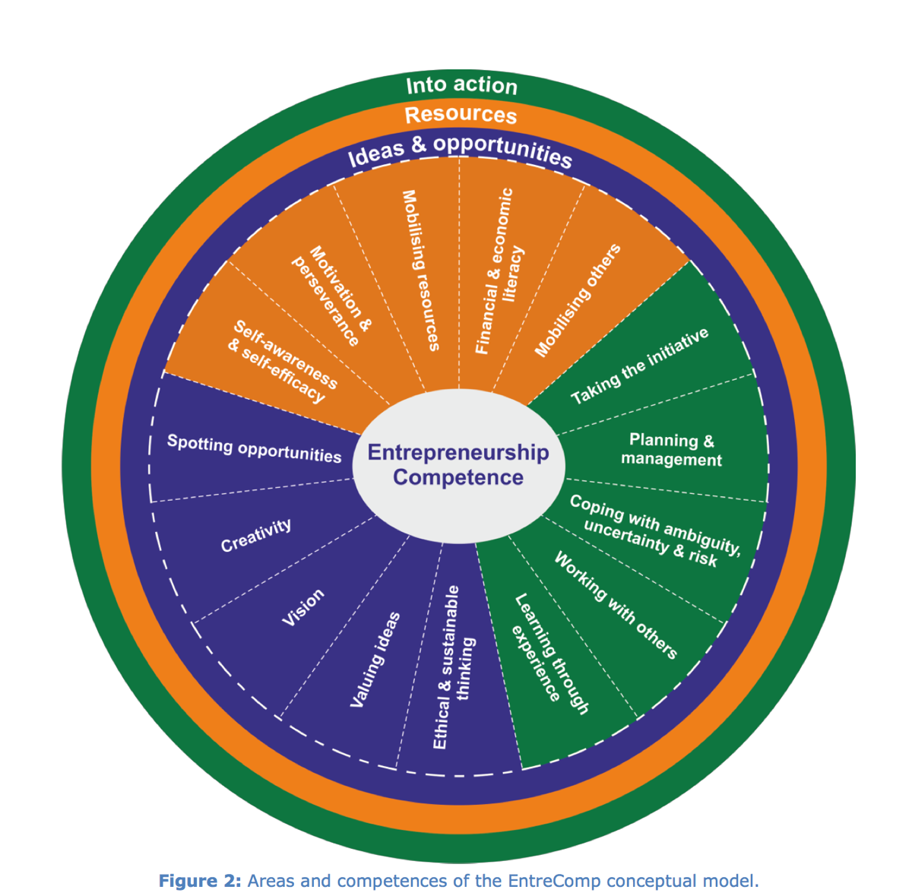
FIGURE 1: AREAS AND COMPETENCES OF THE ENTRECOMP CONCEPTUAL MODEL

There is no single core competence in EntreComp and the competences are of equal importance. The competences are numbered to allow ease of reference, but the order in which they are presented does not imply a sequence in the acquisition process or a hierarchy. A learning activity or development tool may address only 1 competence, or develop all 15 competences.

Depending on where and how EntreComp is used, it is reasonable to expect that emphasis be placed on some competences more than others, or that the model is adapted with less competences prioritised to mirror a particular entrepreneurial learning process or experience.

In other words, the EntreComp wheel can be seen as a simple starting point for understanding and interpreting what is meant by the entrepreneurship competence, and can be used as a guide for designing interventions to address the particular needs of specific target groups.

Useful background reading:
EntreComp into Action is a guide for using EntreComp. It provides an introduction to the EntreComp framework and shares 70+ practical examples of how EntreComp can be used including cases studies, tools and other ideas. (https://publications.jrc.ec.europa.eu/repository/handle/JRC109128)

