

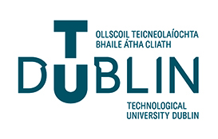

**Spring Semester - May 2024 Exam Timetable**

**Bachelor of Science (Hons) in Pharmaceutical Science**

**Joint programme with NJ Tech and TU Dublin – Tallaght Campus**

**School of Science & Computing**

**Department of Science**

**09:30 Irish time = 16:30 NJUT**

* **Please ensure that you are in possession of a current ID card.**
* **TBC = To Be Confirmed**

|  |  |  |  |  |
| --- | --- | --- | --- | --- |
| **BACHELOR OF SCIENCE (Hons) IN PHARMACEUTICAL SCIENCE – YEAR 1** | | | | |
|  |  | **TA_SCPHA_B – Year 1** |  |  |
| **Date** | **Day** | **Subject** | **Time** | **Location** |
| **9th May** | **Thursday** | **Chemistry 2** | **09:30** | **NANJING** |