
December 2025 - Key Brightspace Information

Dear colleagues,

Just a quick reminder about some Brightspace processes to help you prepare for Semester 2.

- Due to the Brightspace integration with Banner 9 module shells for Semester 2 are already available under the 2025-26 tab in Brightspace.
Semester 2 shells will have the text Jan-May Academic Term 2025/26 displayed in the header image.

- Module enrolment is now controlled and automated based on lecturer assignment to CRN(Course Reference Number) in Banner 9.
You have been enrolled on all modules based on the CRNs you are associated with in Banner 9.

- For enrolment to be updated you must use the appropriate form for your faculty:
Faculty of Engineering and Built Environment: https://forms.office.com/e/j75TeRmTik
Faculty of Computing & Data: https://forms.office.com/e/j8eEXFpdN8
Faculty of Arts & Humanities: https://forms.office.com/e/u7L8xmeznc
Faculty of Sciences and Health: https://forms.office.com/e/S8yvhHZNsM
Faculty of Business: https://forms.office.com/e/EuxXyVm8Fi
- Your module classlist will be automatically populated if the student has selected the correct CRN during Student Self Service Registration.
Alternatively, you can manually enrol your students or make your module Discoverable.
Full instructions are available here.

- Your 2025-26 modules for semester 2 will be empty shells. It is a quick process to import existing content.
You can import the content from the 2024-25 version of the module. This takes about 2 minutes per module, please view the following video: Copy Existing Content into an empty Brightspace Shell

- For modules which you have not taught previously, please review the following 2 guides.
  - Building out your module from scratch (part 1)
  - Building out your module from scratch (part 2)
For more information about the modules please view our FAQ’s.

I have multiple Brightspace modules - how do I identify the correct one to use?
Please check the module code in Brightspace via Module Tools > Module Admin > Module Information > Module Code (which contains the module code, CRN and programme code).
For Example:
TXXN-3001-20466-TU000-FT-202520
Module-Code-CRN-TU Programme Code-Full time or Part time-Academic Term

Important things to remember:
- Brightspace modules are unique and should not be used from semester to semester or year to year
- Students retain access to the modules they have taken from year to year over the course of their programme, therefore no modules where teaching has concluded should ever be cleared out, made inactive, reset and/or re-used with a different cohort.
- Modules will appear ‘greyed out’ to students and will not be accessible to students until the lecturer amends the start date.
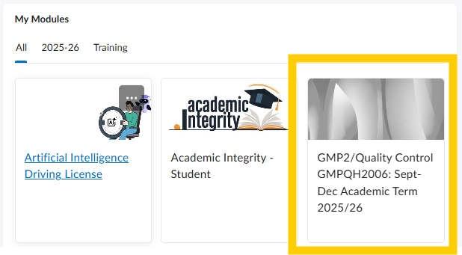

Make your Brightspace module available to students:
To make your module available you must modify the start date. In your module navigate to Module Tools>Module Admin>Module Information and change end date as appropriate, remember to click Save)
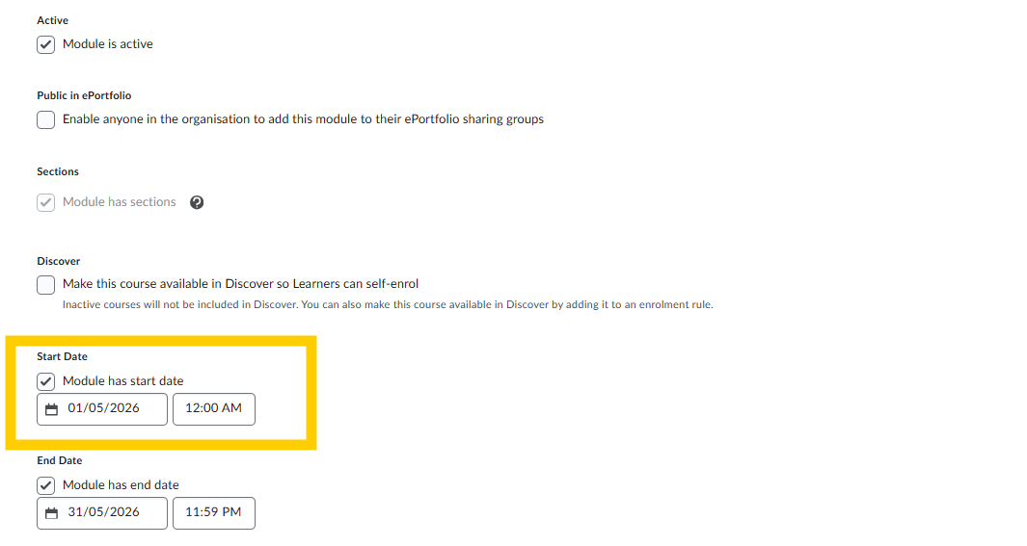

Populating the Classlist
- Your module classlist will be automatically populated if the student has selected the correct CRN during Student Self Service Registration.
Alternatively, you can manually enrol your students or make your module Discoverable.
Full instructions are available here.
- To make self-enrolment via Discover on semester 2 modules easier for all students, please ensure self- enrol via Discover has been disabled for your semester 1 modules.
This will ensure that only semester 2 modules show for students when they search for modules.

Questions or Concerns
Please submit your queries via our Brightspace Support Form

Please see our Microsite www.tudublin.ie/Brightspace

