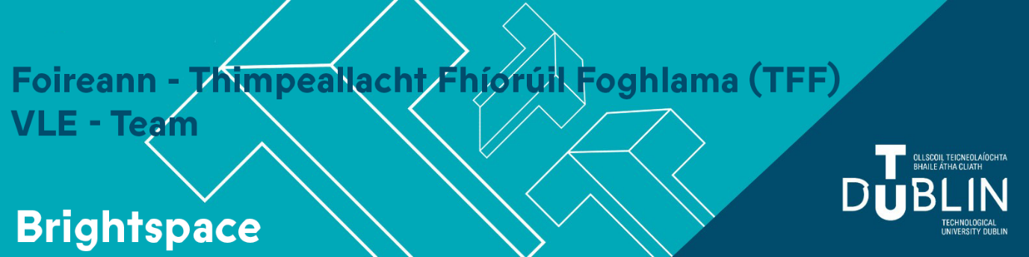End of Semester Key Brightspace Information

Next Academic Year 2026-27
The new blank Brightspace module shells for the 2026-27 academic year are expected to be available in late August 2026.
Staff will be auto enrolled on their empty Brightspace module shells for the 2026-27 academic year based on CRN assignment in Banner.
Please ensure your banner record is up to date by following local faculty/school processes before the end of July.
Discover will not be available for the 2026-27 academic period. Students will be auto enrolled on modules once they have completed the Banner Student Self Service registration process.
The ability to manually enrol colleagues and students will also be removed.
You can import content from your exiting modules in the previous academic year. Please view Importing content into your Brightspace modules.
For modules which you have not taught previously you will find all necessary instructions in the following guide which provides an overview of what Brightspace can be used for.
If you wish to start developing content for 2026-27 Academic year in advance of September 1st you could do so in your Brightspace Sandbox Environment. It is a quick and easy process to import that content into your 2026-27 Brightspace module shells.
Brightspace accounts for new students will be created in late August and will continue to be created on a nightly basis over the course of the year.
Apprentice Students will now be included in the autoenrollment process and new blank apprentice Brightspace module shells will also be provisioned by default.

Current academic year 2025-26
2025-26 modules must remain available to your students for the duration of their studies with TU Dublin.
Brightspace modules are unique and should never be cleared out, reset and/or reused with a different cohort.
A note about end dates: The end date on your module can be set by you.
Semester 1 modules (202510) had a default end date of December 31st 2025.
Semester 2 modules (202520) had a default end date of May 31st 2026.
Semester 3 modules (202530) had a default end date of August 31st 2026
If your module is one which is still actively being used for teaching beyond 31st August 2026 then you can change the end date on your module by navigating to:
Module Tools -> Module Admin -> Module Information
Change the end date as appropriate.
Click: Save
Please turn off Discover on your 2025-26 module to prevent any further enrolments
In your module navigate to:
Module Tools > Module Admin > Module Information
untick: Make this course available in Discover so Learners can self-enrol.
Click: Save

Training
To help you prepare for the next academic year please see our full semester 1 training schedule.

Data Retention

Student Submissions
In line with the Faculties and Schools data retention schedule all student activities including assignment submissions, quiz responses, discussions are deleted and purged 13 months after the end of the academic year.

2019-20 & 2020-21 Academic Periods
All Brightspace shells in the 2019-20 academic period and their associated data will be deleted and purged from Brightspace on June 26th 2026. Data in the 2020-21 academic period will be deleted on October 1st 2026. If you would like to retain any of your content, please view the following video: copying existing content into a course.

New Content Experience
The current Brightspace interface is referred to as the Classic experience. This is expected to reach its end of life(EOL) by the end of 2026.The Brightspace New Content Experience will be implemented in Brightspace for the start of Semester 2 2026/27.
In preparation for this upgrade, we will be enabling the ability for you to toggle on and off the New Content Experience (NCE) in your Sandbox environment.
Please read New Content Experience vs Classic Content in Brightspace: Understanding our Content Experiences for further information.

Accessibility
The accessibility of digital learning content in European universities is governed by Directive (EU) 2016/2102. This directive is a legally binding framework that applies to all digital content created and distributed by universities, including documents, videos, and learning platforms made available for students, staff, and the public. For full details, and support as you make your content accessible for students, please visit: Building Accessible Content | TU Dublin
For training resources please visit the Complete Directory of D2L Academy Offerings - Brightspace and find a course Brightspace Toolkit for Accessibility in UDL, which has a lot of guidance on making Brightspace content accessible.

Questions or Concerns?
Any questions about the above can be logged via the online support form.
A comprehensive set of guides is available from https://www.tudublin.ie/brightspace

Sincerely
Eamonn

