Manual Enrolment of Students Awaiting Supplemental Examination Results in Brightspace
This process should be used when a student is awaiting supplemental examination results and requires access to a Brightspace module before their enrolment status has been updated through Banner.
A student awaiting supplemental examination results requires access to the module Respiratory Physiology 1 (PHYS3823) for Semester 1 2026/27.

Brightspace Module Name:
Respiratory Physiology 1 PHYS3823: Sept-Dec Academic Term 2026/27 CRN:19519
Brightspace Module Code:
PHYS-3823-19519-TU868-FT-202610
The student does not know the CRN.
Student Process
The student emails the lecturer requesting access to the Brightspace Shell:
Respiratory Physiology 1

Lecturer Process
Step 1: Select requested course from your course’s widget.
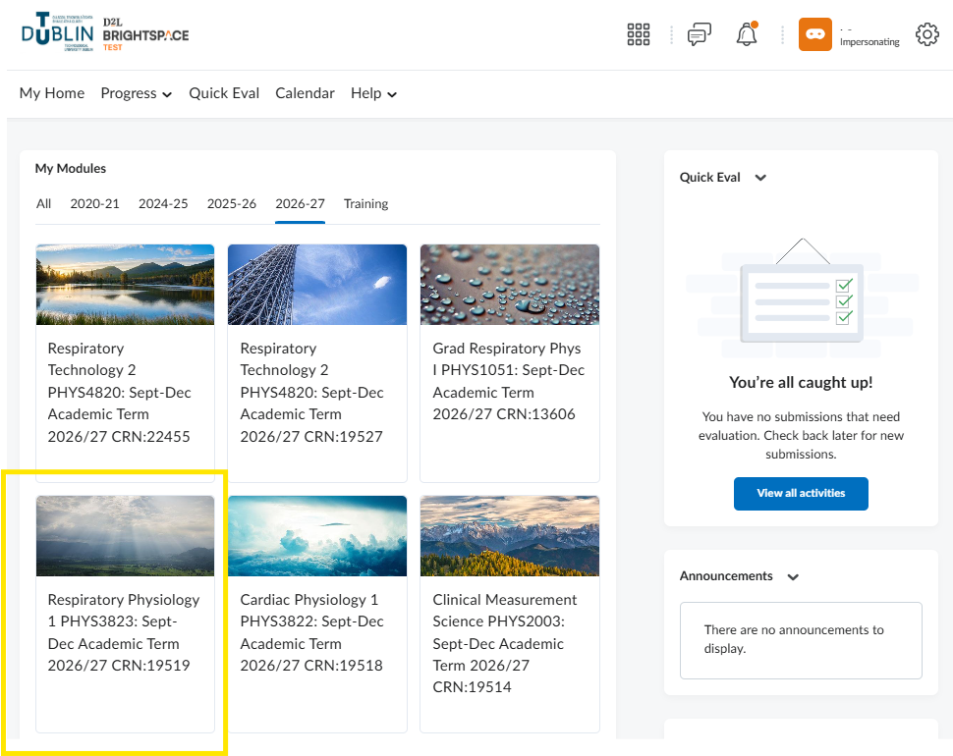
Step 2: Select Module Tools from the main menu followed by Module Admin
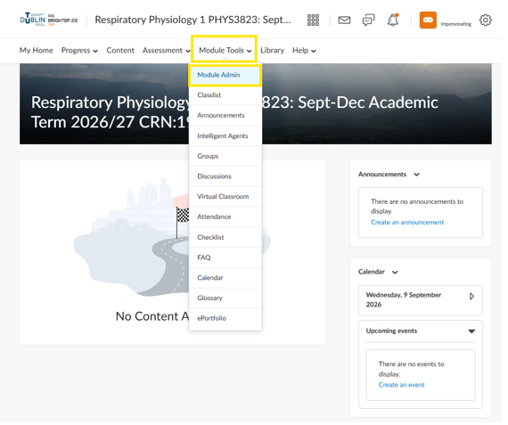
Step 3: Select Classlist from the Learner Management section.
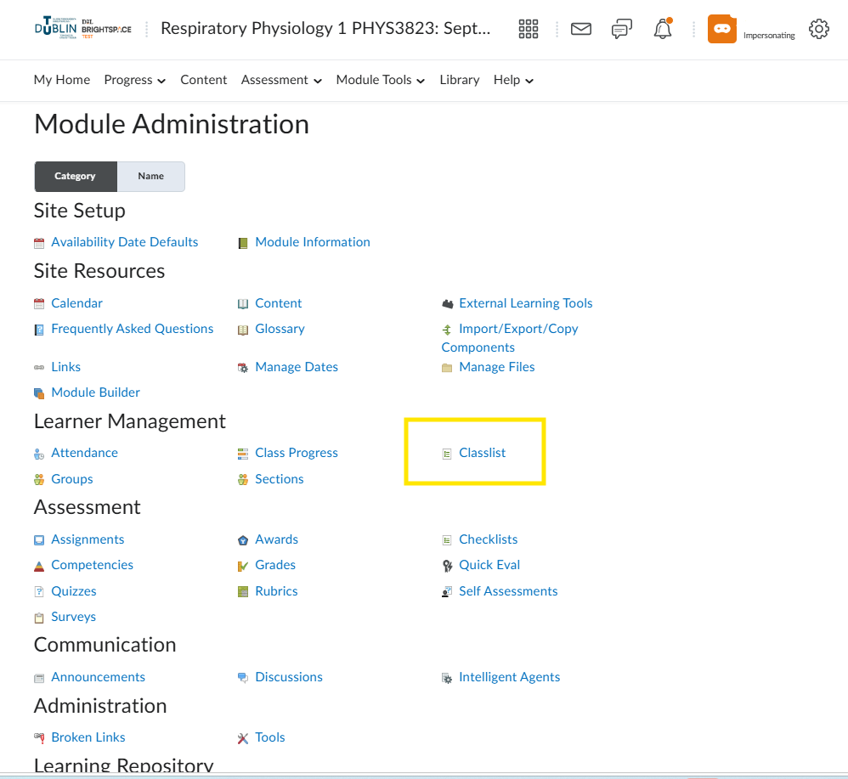
Step 4: Select Add Participants followed by Add existing users.
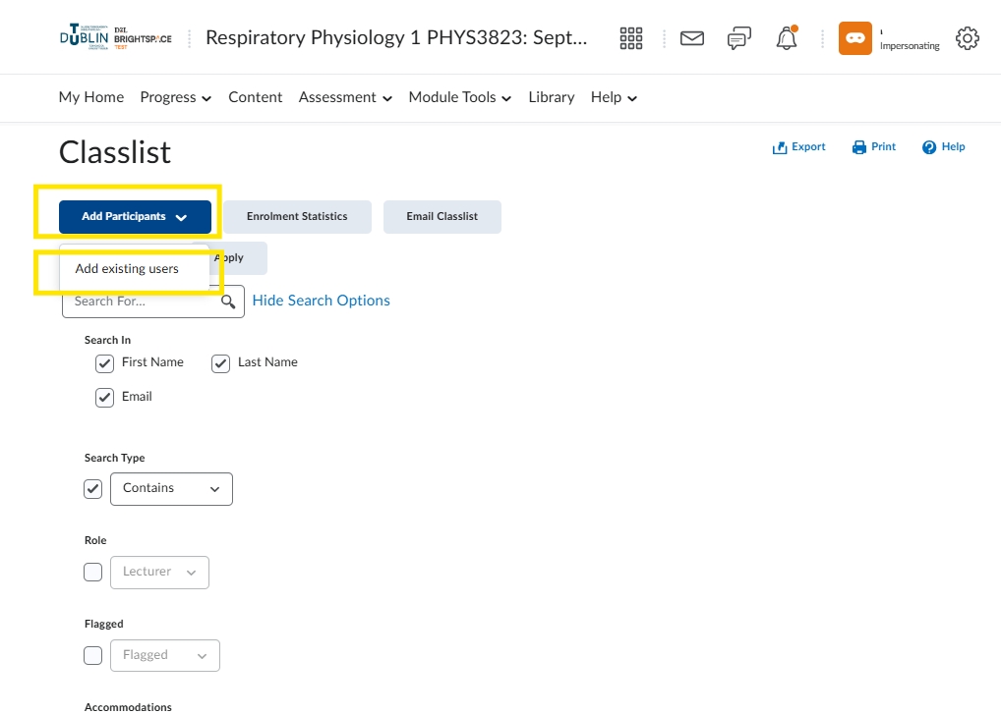
Step 5: Search by Student email address
Select the tick box.
Select Role of Student
Select Section
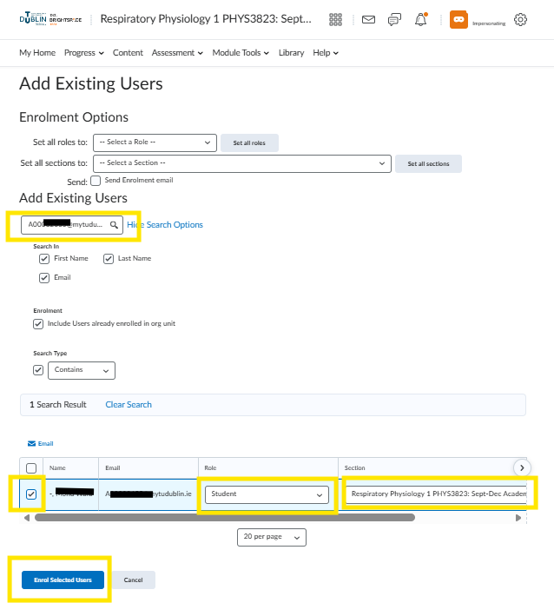
Click Enrol Selected Users
Step 6: Confirm that the student appears in the Classlist and has been assigned the Student role correctly.
Important: For Cross-Listed Modules, students must be enrolled in both the child module and the associated Cross-Listed module to ensure they can access all learning materials and activities.

