Activating the New Content Experience
The New Content Experience (NCE) toggle option within your sandbox module can be turned on when you click on Content.
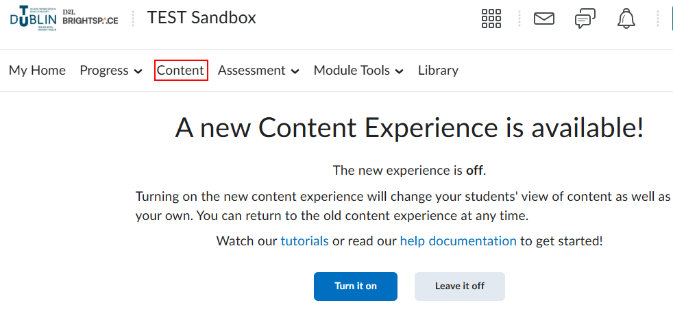

Clicking on Turn it on, will switch to the NCE view.

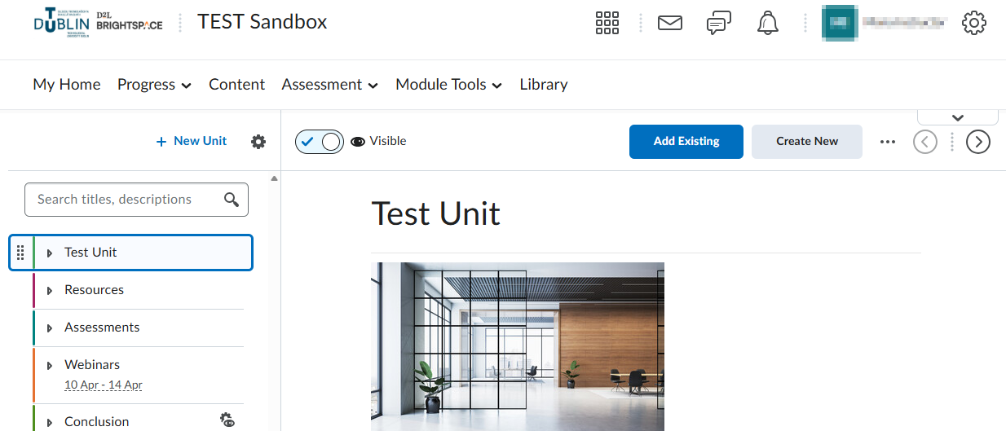

To switch back to Classic content view, click on the chevron down arrow as per screenshot.

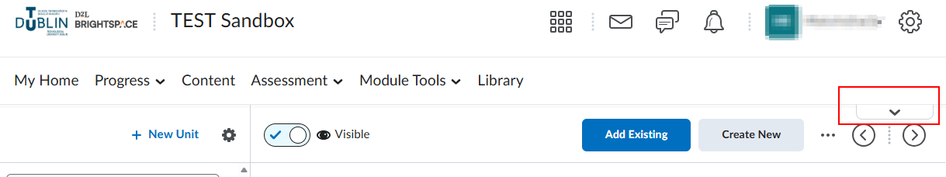

You can then select Turn it off and you will be prompted to select a reason for switching.

