Accessing Brightspace for HPALs – Quick Guide
Step 1: Request Your Banner Account
- Brightspace access is linked to your Banner account.
- If you see the following error when logging into Brightspace you do not have a Brightspace or Banner account.
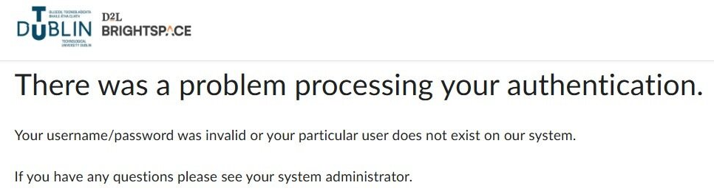
- You must request a Banner Account using the following form.
Step 2: Confirm Brightspace Access
- Once your Banner account is active, Brightspace access will be automatically provisioned.
- Log in at: https://brightspace.tudublin.ie using your TU Dublin credentials.
- If you can log in without errors, your access is confirmed.
Step 3: Get Access to Module Shells of the courses you are teaching
- Brightspace module shell enrolment is linked to CRNs (Course Reference Numbers) assignment in Banner.
- You must be assigned to the relevant CRNs in Banner to access the corresponding Brightspace shells.
- If you do not see your modules, Faculty Deans have approved a standard process for requesting CRN assignment for Semester 2.
Please complete this form: SRMS - Banner 9 - CRN Assignment Request – Fill out form
Requests will be processed by your Faculty, not the VLE team.
Step 4: Get Support on the VLE
- For help using Brightspace, visit the TU Dublin Brightspace Microsite:
Connect | Brightspace for Staff | TU Dublin

