Brightspace Discover Tool & Manual Enrolment
Contents
Step 1 Look up Brightspace Module Code 1
Step 2 Request students update registration details in SSB (Banner) 2
Step 3 Enable Discover 4
Manual Student enrolment 9

Please note the following:
- In Order to use the Discover tool and/or manual enrollment you must be assigned to the correct CRN in Banner 9 and therefore have access to the corresponding Brightspace Shell (module).
- Cross Listing is not available with Discover enabled.

Step 1 Look up Brightspace Module Code
- Within the Brightspace Courses Widget select the module
- Look up the Brightspace module code
Module Tools -> Module Admin -> Module Information
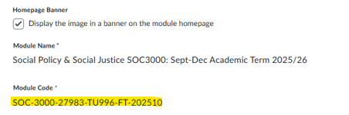
SOC-3000-27983-TU996-FT-202510
Please note that the Brightspace module code contains the following information:

Step 2 Request students update registration details in SSB (Banner)

- Provide the student with the CRN from the Brightspace Module Code e.g. SOC-3000-27983-TU996-FT-202510 and request that they open Banner Self Service
https://ssb.tudublin.ie/BannerGeneralSsb
And complete the registration process as outlined here:
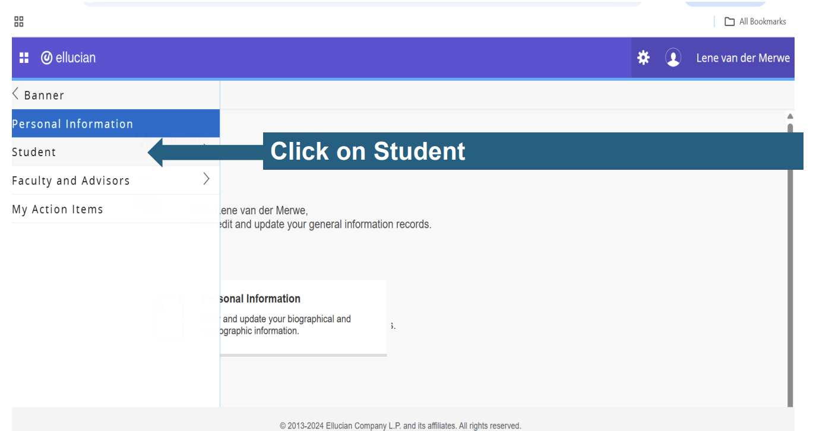
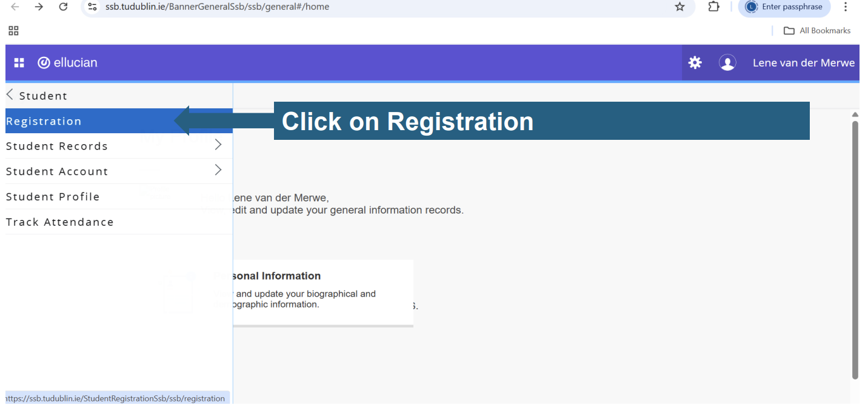
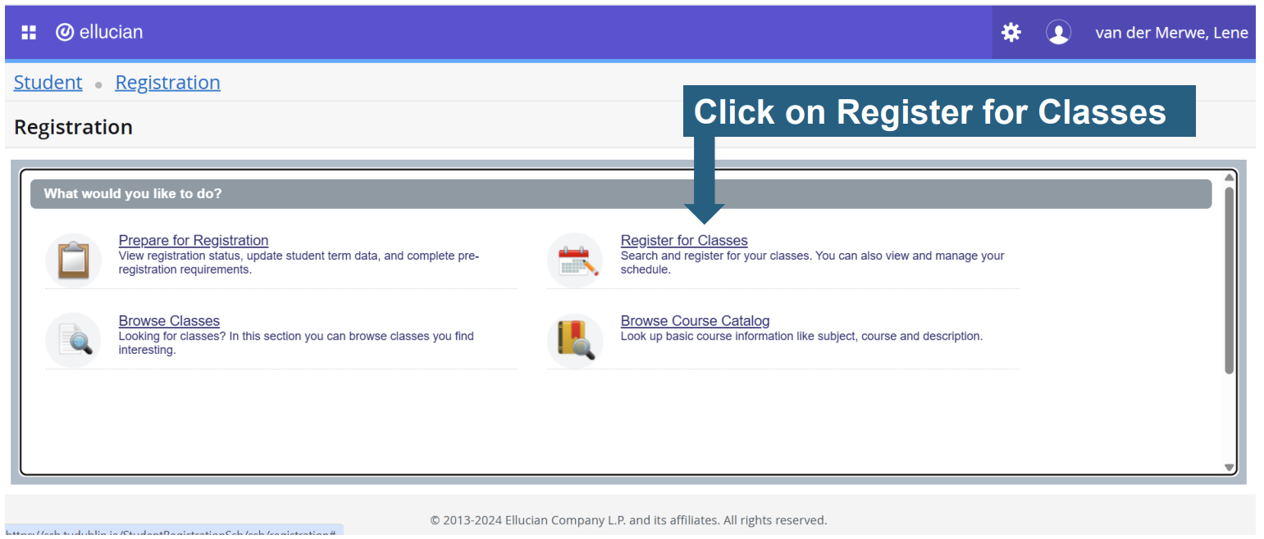
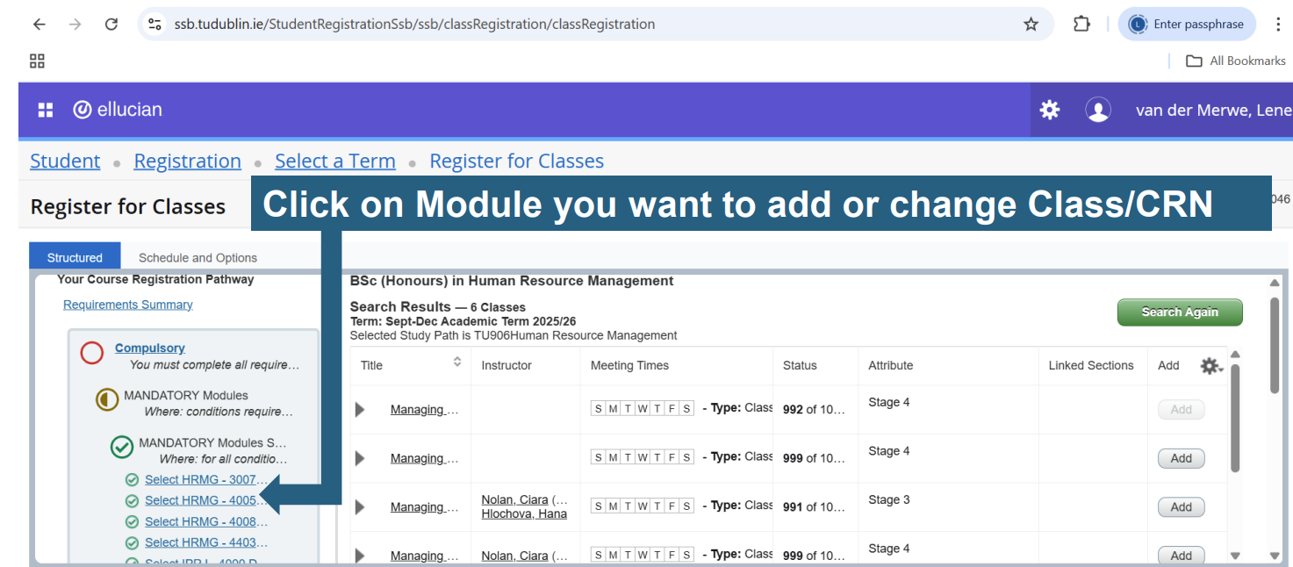
SOC-3000-27983-TU996-FT-202510
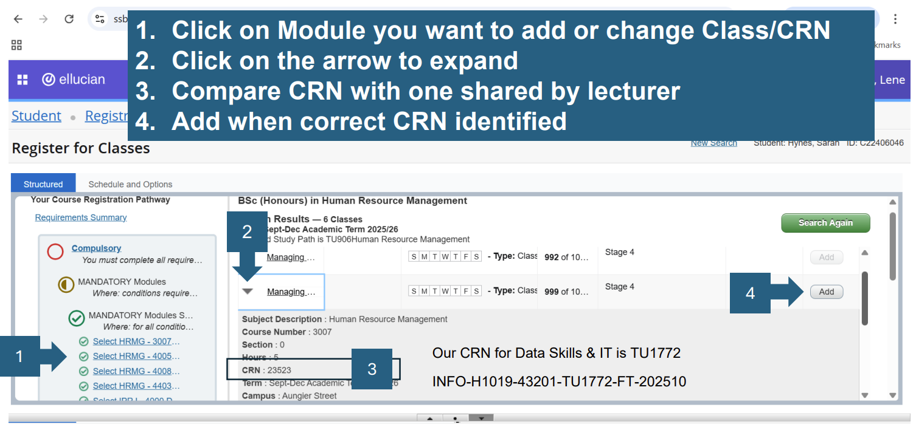
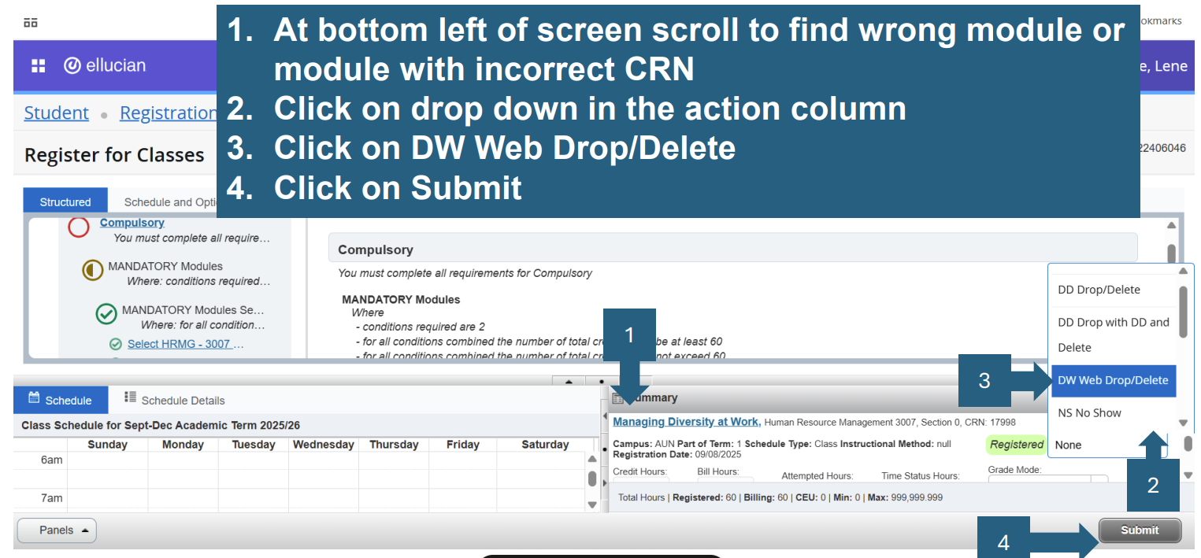

Brightspace Module Enrolment is instantaneous when the student selects the CRN. The corresponding Module Shell will appear with the students’ Courses Widget.

Please note:
- If all students have now correctly registered in SSB there is no need to proceed any further, however if students are unable register or select the correct CRN on SSB please proceed to make your module “discoverable” as per instructions below

Step 3 Enable Discover
- Within the Brightspace Courses Widget select the module you want to make “Discoverable”
- Module must be made Discoverable by ticking the box
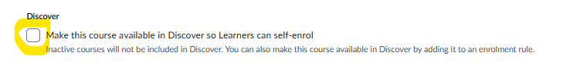

- Choose the enrolment rule to ensure only students can enrol in your module.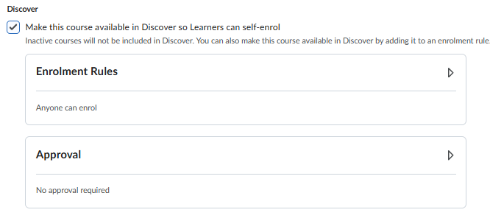
  - To Select the Enrolment Rule
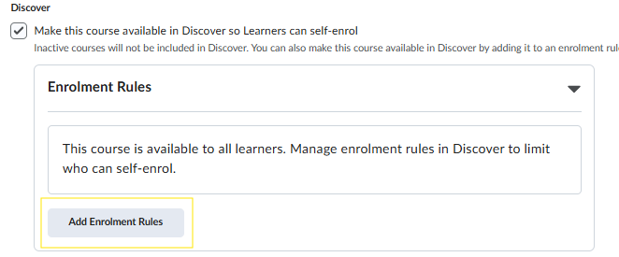
- Click Add Enrolment Rule.
  - Select D2L Support Dev Assist – All Discoverable Courses
This ensures only students can enrol in your Brightspace Module
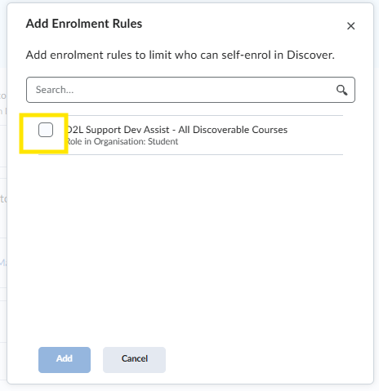
  - To further restrict enrolment and control your classlist.
Select Require approval for self-enrolment requests.
You can add an additional step of requiring an answer to be provided by the student.
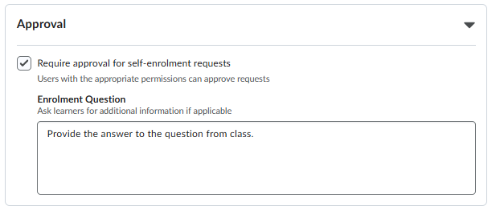

- Start date must be edited and set to today’s date.
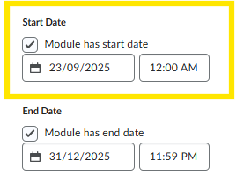

- Description must be populated in the following format
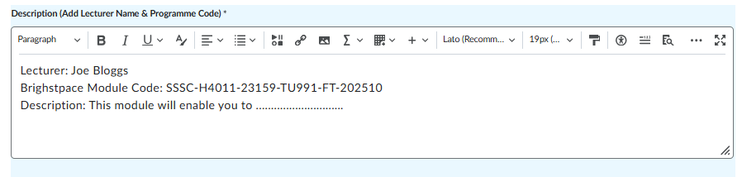
If the Brightspace module code which contains the CRN is not added fully the student will be unable to find the module when searching with Discover.

- Provide student with the full Brightspace module code e.g. SSSC-H4011-23159-TU991-FT-202510 and request them to search using Discover
Please note that the Brightspace module code contains the following information:
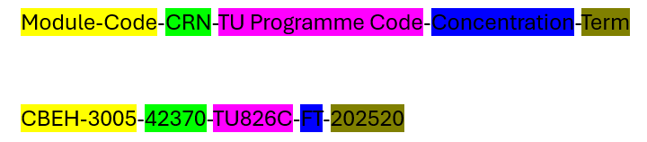

This is the Student View of Discover
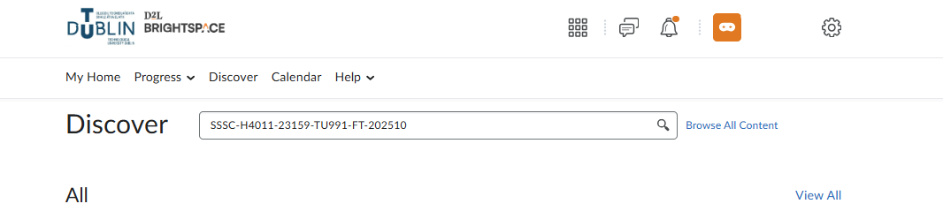
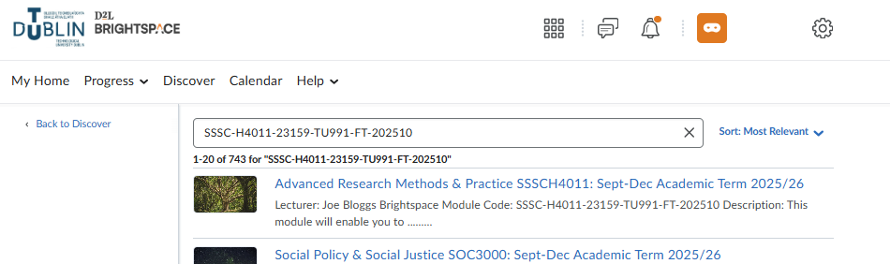

Ensure that student confirms it is the correct module by reviewing the Course Info.
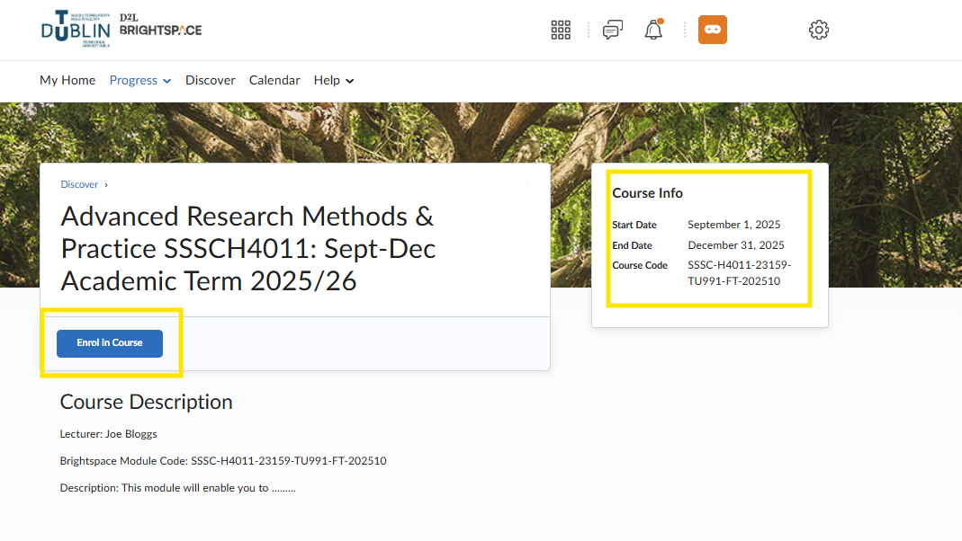
- Instruct student to Select: Enrol in Course and Click OK
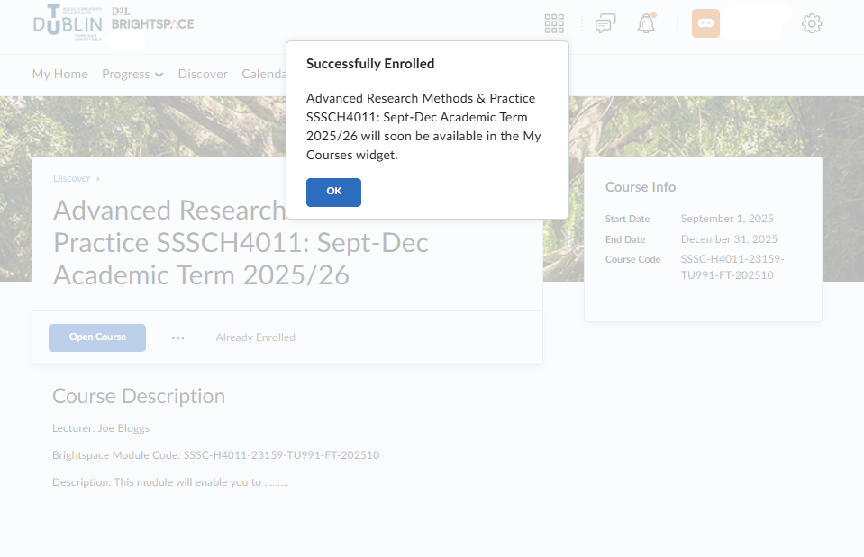
- If Approval has been set by lecturer, the student will be asked to Request Approval.
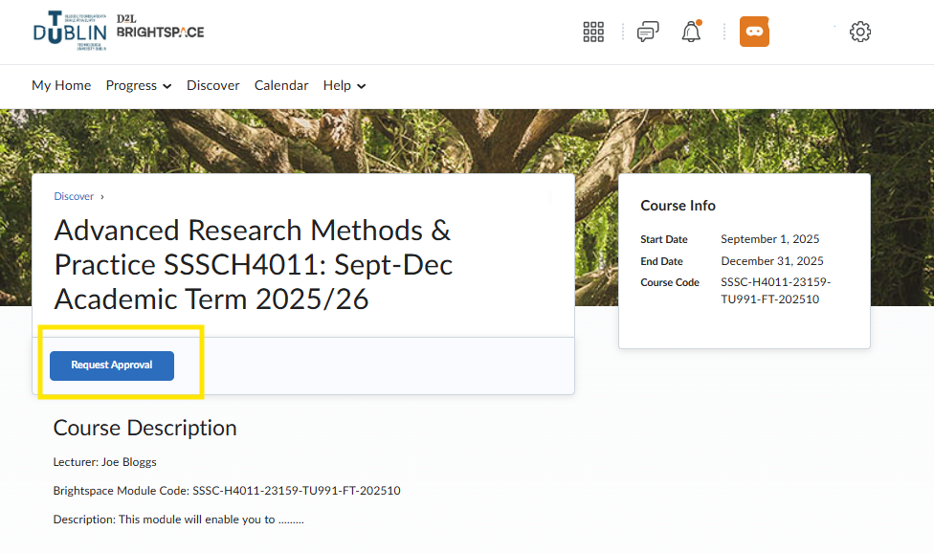
- Approve Access requests through the classlist
Enrolment requests are visible via Module Tools -> Classlist
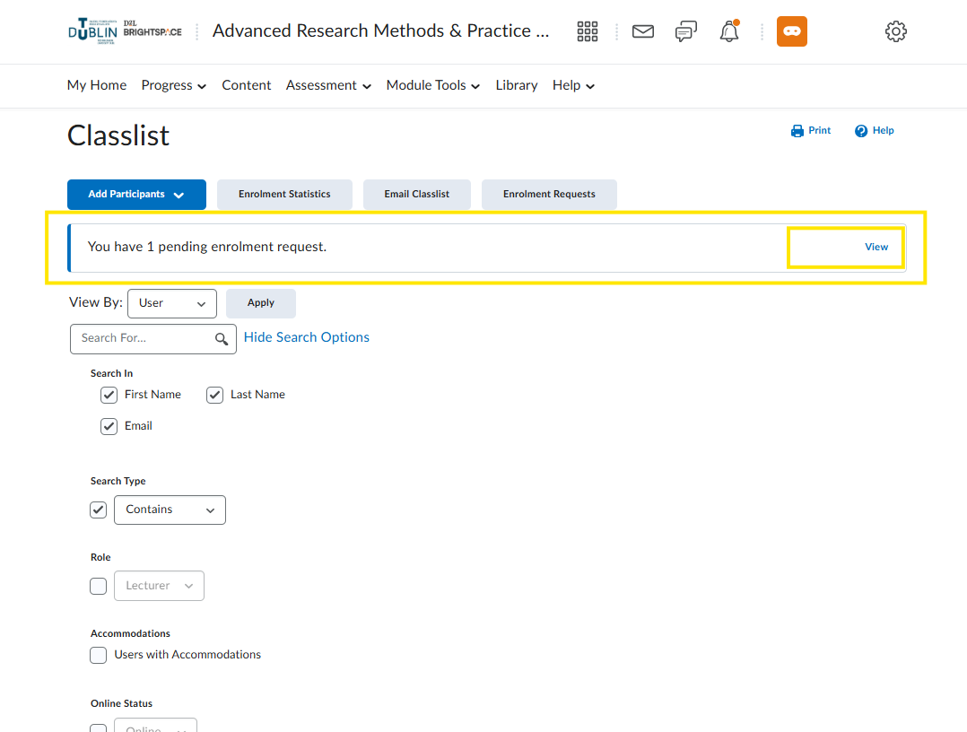
Click View
- Select the Student requests and Select Approve or Decline
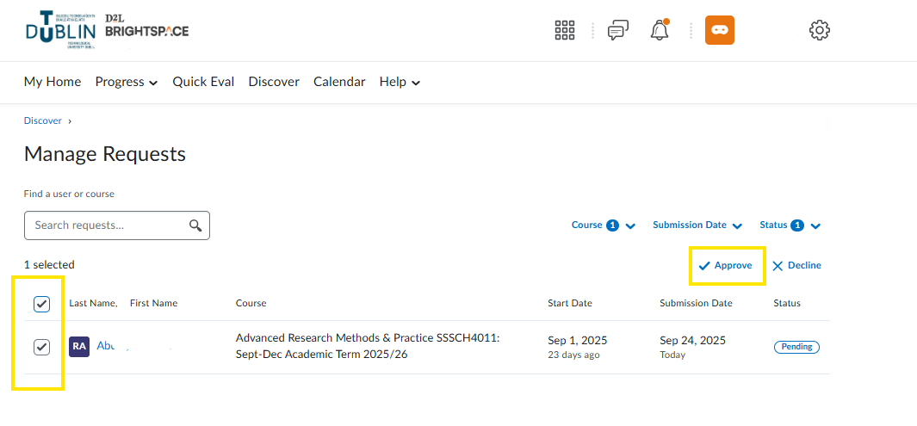

This student will now appear in your classlist

Manual Student enrolment
This step can be used to manually enrol individual students onto your Brightspace module. This step is not necessary if the student has successfully registered on the correct CRN in SSB (Step 2) or if the student has successfully used the Discover Tool to enrol on the Brightspace Module.
- Access the Brightspace Classlist tool
Module Tools -> Classlist
- Add Participants
  - Add Existing Users
Add Existing Users
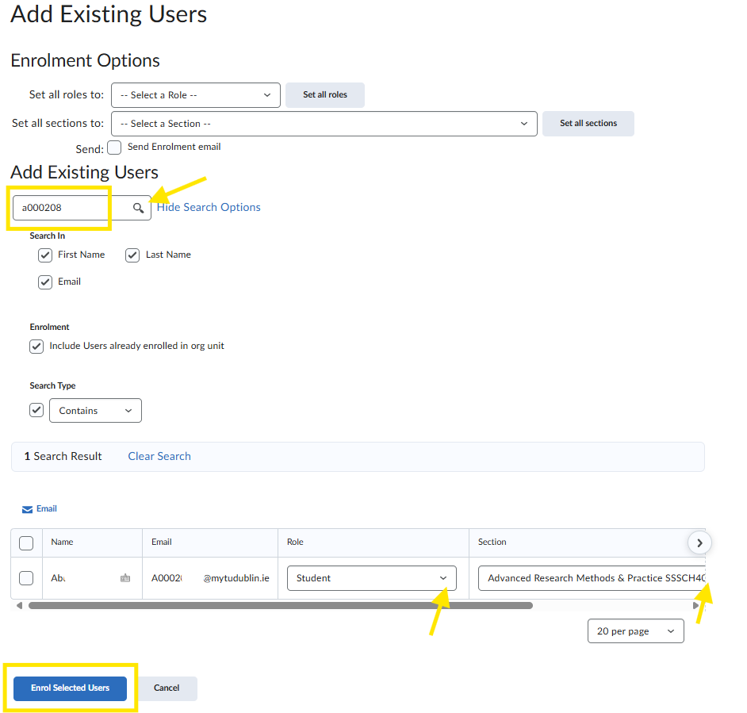
- Search for the student using their email address
- Ensure the Role of Student is Selected and choose the default section
- Click Enroll Selected Users
- Repeat as required

