Cross Listing Common Modules with different student cohorts
Brightspace modules are provisioned based on data linked from Banner.
Student enrolment on Brightspace modules is directly linked to a students' registration choices made in Banner Self Service.
With the integration we can accommodate combining multiple cohorts of students on a single Brightspace Shell.
The behaviour will be:
(fictitious course codes and programmes, screen grabs)
Student 1 along with their classmates are auto enrolled on the same Brightspace module based on their registration choices.
For Example:
Accounting and Finance Work Placement on TU001
ACCH H3027 CRN 12345
Brightspace Module Code ACCH-H3027-12345-TU001-FT-202610
The Module is "greyed out" until the lecturer sets the start date.
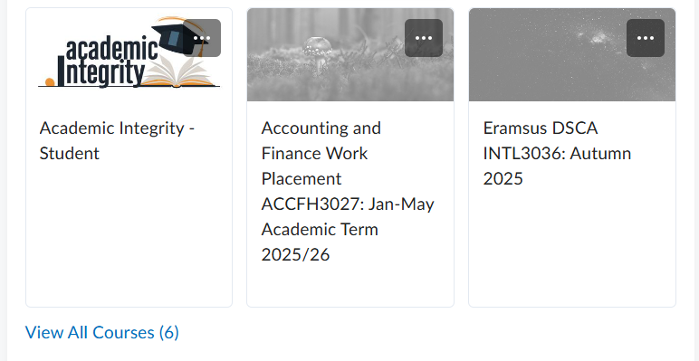
Student 2 along with their classmates are auto enrolled on a different instance of the same Brightspace module based on their registration choices.
For Example:
Accounting and Finance Work Placement on TU002
ACCH H3027 CRN 54321
Brightspace Module Code ACCH-H3027-54321-TU002-FT-202610
Each student is presented with a corresponding Brightspace Shell in their Courses Widget.
The Module is "greyed out" until the lecturer sets the start date.

As a lecturer you will see two instances of the module within your courses widget.
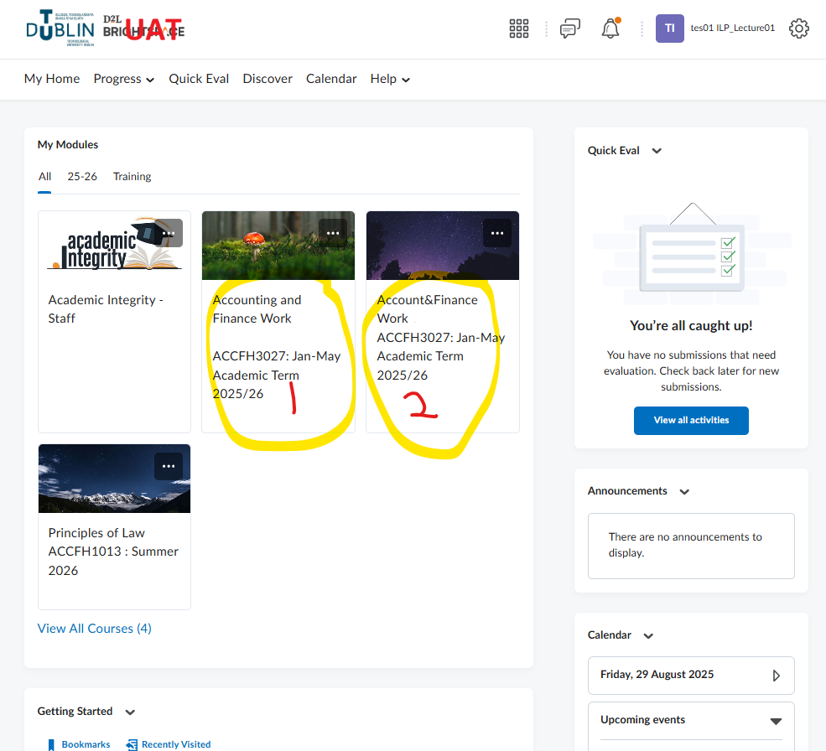
If you want these cohorts of students combined on a single common Brightspace Shell, please log your query via the online support form requesting:

We will work with the Banner team to "Cross List" these two or multiple instances into a single Brightspace module which will have a slightly different title.

Once Cross listing has been processed you will be presented with an additional “Cross Listed” Brightspace Shell
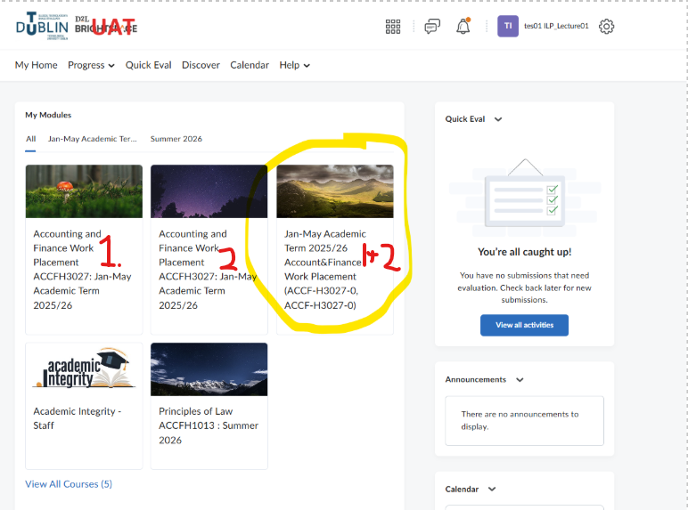
The new “Cross listed” Shell should be populated with the course content for the newly combined cohorts of students which will be present in the Classlist.
The start date will also need to be set.
For student 1 & student 2 they will see an additional shell which you have made active, and the original shell will remain “greyed out”.