
September 2025 - Key Brightspace Information for Staff
Brightspace has been integrated with Banner 9, a major upgrade designed to streamline access to essential services including Brightspace bringing significant enhancements to the student and staff experience.

- The new Brightspace module shells for the 2025-26 academic year are now available on Brightspace https://brightspace.tudublin.ie and will appear in a new 2025-26 tab.
- Module enrolment is now controlled and automated based on lecturer assignment to CRN(Course Reference Number) in Banner 9.
- You have been enrolled on all modules based on the CRNs you are associated with in Banner 9.
- For enrolment to be updated you must use the appropriate form for your Faculty
Faculty of Engineering and Built Environment: https://forms.office.com/e/j75TeRmTik
Faculty of Computing & Data: https://forms.office.com/e/j8eEXFpdN8
Faculty of Arts & Humanities: https://forms.office.com/e/u7L8xmeznc
Faculty of Sciences and Health: https://forms.office.com/e/S8yvhHZNsM
Faculty of Business: https://forms.office.com/e/EuxXyVm8Fi
- Your module classlist will be automatically populated based once the student makes the correct choice during Student Self Service Registration.
- Your 2025-26 modules will be empty shells. It is a quick process to import the content.
You can import the content from the 2024-25 version of the module. This takes about 2 minutes per module, please view the following video: Copy Existing Content into an empty Brightspace Shell
- For modules which you have not taught previously, please review the following 2 guides.
  - Building out your module from scratch (part 1)
  - Building out your module from scratch (part 2)
For more information about the modules please view our FAQ’s.

Changes for Staff

- Students will be auto enrolled on modules once they have completed the Banner Student Self Service registration process.

Changes for Students
- Students will be auto enrolled on their Brightspace modules for the 2025-26 academic year only when they have completed the Banner Student Self Service registration process.
- All students have been enrolled on the Academic Integrity module. By accepting the student affirmation of Academic Integrity for assessment in TU Dublin Programmes which is presented on initial login to Brightspace they are undertaking to complete the Academic Integrity module within Brightspace.
- When student logs into Brightspace having completed Student Self Service registration they will be presented with their Brightspace modules for the 2025-26 Academic year. These modules will appear “greyed out” and won’t become accessible until the lecturer amends the start date.
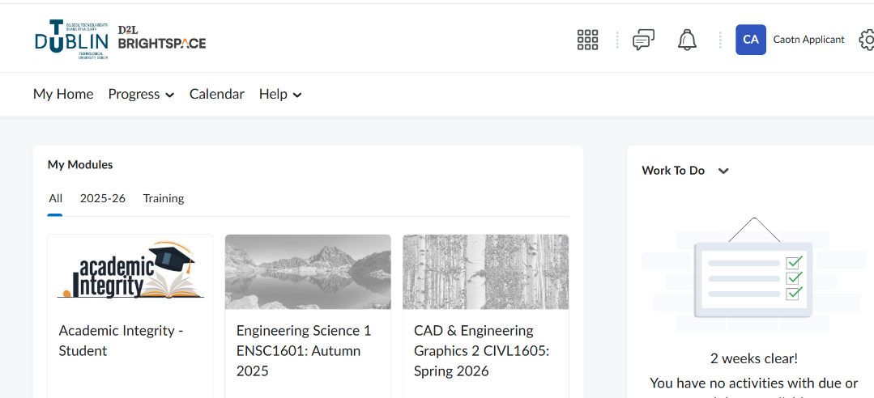

Important things to remember
- Brightspace modules are unique.
- You cannot re-use the same module from semester to semester, or from year to year.
- Students retain access to the modules they have taken from year to year over the course of their programme, therefore no modules where teaching has concluded should ever be cleared out, made inactive, reset and/or re-used with a different cohort.
- Do not un-enrol students and do not delete assignments in 2024-25 modules
To Make your Brightspace module available to students:
To make your module available you must modify the start date.
How to change Start Date: In your module navigate to “Module Tools - Module Admin
- Module Information” and change end date as appropriate, remember to click Save) 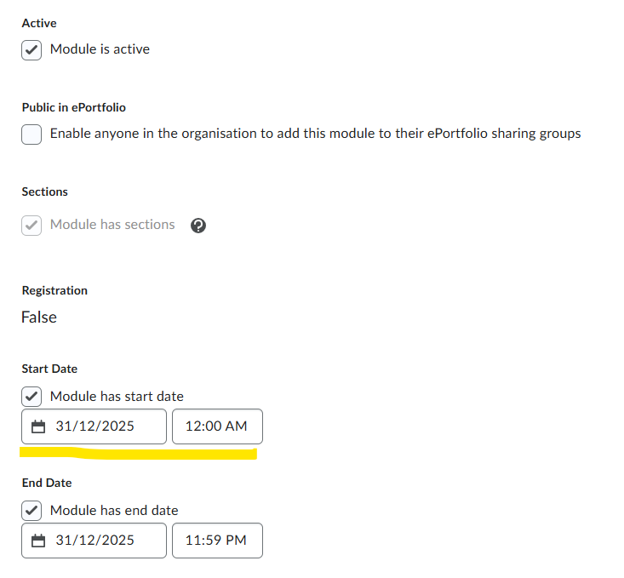

Student Submissions to Brightspace (Assignments, Quizzes etc.)
Because Brightspace modules remain available to students for the duration of their studies, so do any assignments/quizzes/other work generated by students and submitted to Brightspace.
This work remains in Brightspace until such time as it is:
(a) deleted by either the student or the lecturer
(b) the student account is removed from Brightspace

Training
Please see our full training schedule to prepare for Semester 1 2025: Connect | Brightspace Training & Support For Staff | TU Dublin

Questions or Concerns
Brightspace support queries or questions will only be responded to when logged on our Brightspace Support Form
Please see our refreshed Microsite www.tudublin.ie/Brightspace

