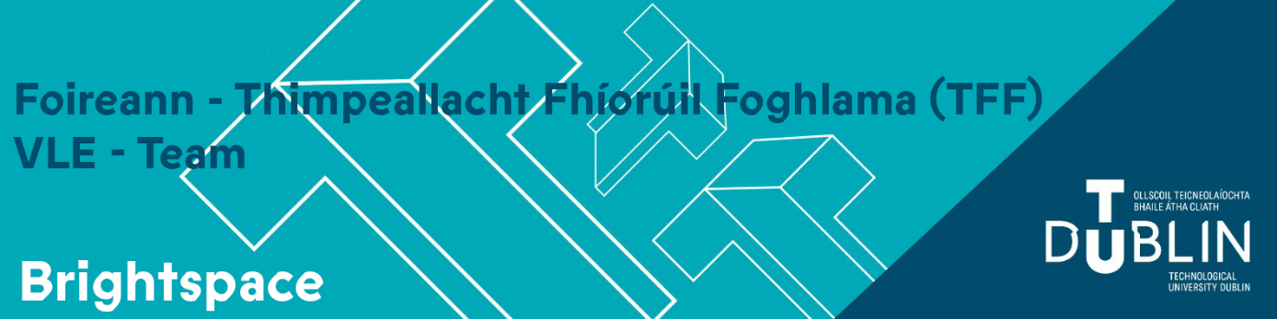
Semester 1 2026/27 - Key Brightspace Information
Brightspace module shells for the 2026/27 academic year will appear under a new 2026-27 tab.
Module enrolment is automated and based on lecturer assignment to a CRN (Course Reference Number) in Banner 9.
If you do not see empty module shells for courses, you are teaching the year, requesting CRN assignment will provide you with access to the corresponding Brightspace Shell for the 2026/27 academic year.
To request assignment please follow local School/Faculty processes.
Your module classlist will be automatically populated based on students' module selections during Banner Student Self Service registration.
Your 2026-27 modules will be empty shells. It is a quick process to import the content.
You can import the content from the 2025-26 version of the module. This takes about 2 minutes per module, please view the following video: Copy Existing Content into an empty Brightspace Shell
For modules which you have not taught previously, please review the following 2 guides.
Building out your module from scratch (part 1)
Building out your module from scratch (part 2)

Changes for Staff
Manual enrolment of Staff and Students onto Brightspace Shells is no longer available or required. Students will be auto enrolled on modules once they have completed the Banner Student Self Service registration process. Lecturing Staff must be assigned to the CRN in Banner. Assistant Tutor/Demonstrator enrolments must be requested through the following form: VLE Support Form Academic Period 2026-27
To make your module available you must ensure:
- The module is set to active.
- You must modify the start date.
How to change start date: In your module navigate to “Module Tools -> Module Admin
-> Module Information” and change start date as appropriate, remember to click Save) 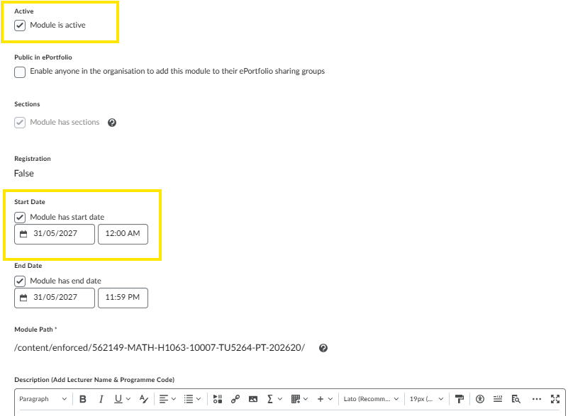
If you have multiple Brightspace modules you can identify the correct one to use using one of the following methods
- You can use the CRN (Course Reference Number) which is displayed in the header image.
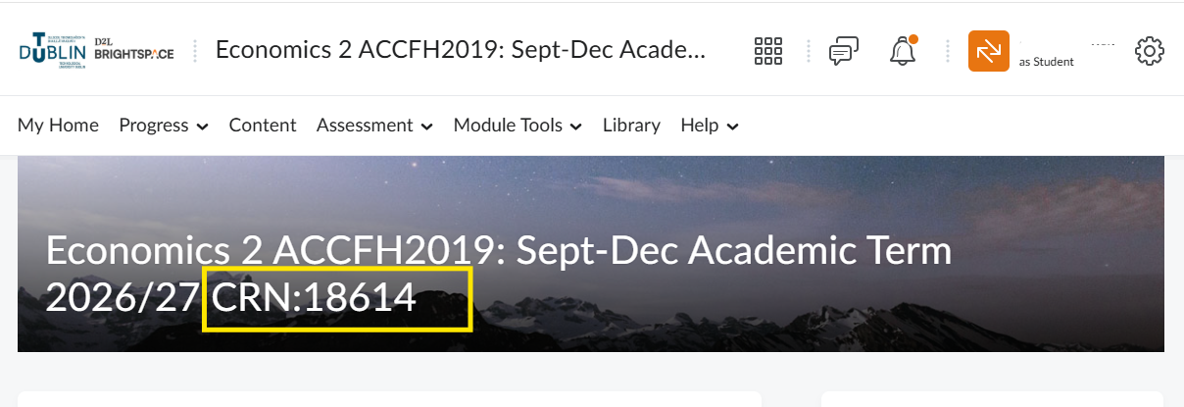
- Alternatively check the module code in Brightspace via “Module Tools -> Module Admin -> Module Information”
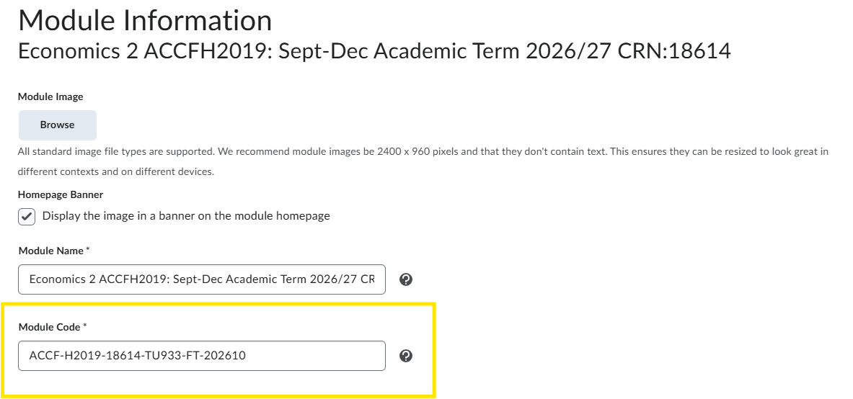
Module Code is constructed as Follows:
ACCF-H2019-18614-TU933-FT-202610
Module-Code-CRN-TU Programme Code-Full time or Part-time-Academic Term

Cross Listing
Cross listing is the process of combining multiple Brightspace shells of the same module into a single Brightspace shell so that instructors can manage content, assignments, quizzes, grades, and communications in one place instead of maintaining multiple separate Brightspace shells. For full details and how to request Cross Listing please read the following guide

Changes for Students
The Discover tool will no longer be available or required.
Students will be auto enrolled on their Brightspace modules for the 2026-27 academic year once they have completed their Banner Student Self Service registration process.
All students have been enrolled on the Academic Integrity module and Artificial Intelligence Driving License.
Students must accept the Student Affirmation of Academic Integrity for Assessment in TU Dublin Programmes which is presented on initial login to Brightspace. They should also make an undertaking to complete the Academic Integrity module.
When the student logs into Brightspace having completed their Student Self Service registration process they will be presented with their corresponding Brightspace modules for the 2026-27 Academic year. These modules will appear “greyed out” and won’t become accessible until the lecturer amends the start date.
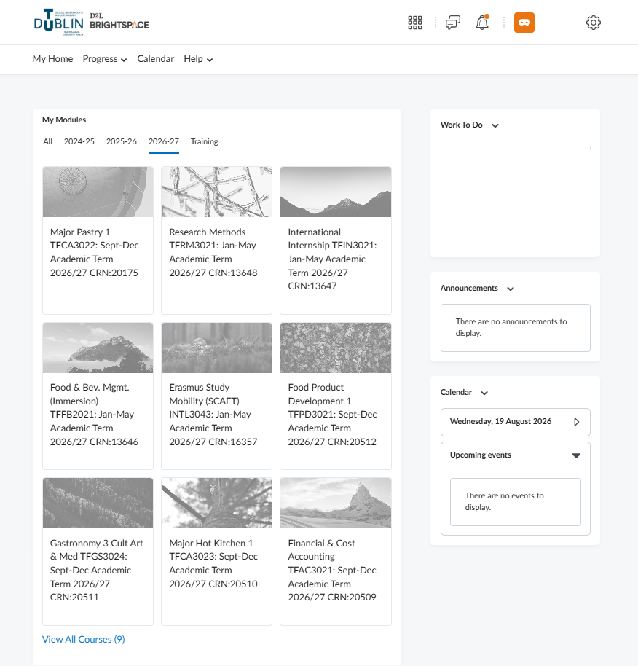

Important things to remember
- Brightspace modules are unique.
- You cannot re-use the same module from semester to semester, or from year to year.
- Students retain access to the modules they have taken from year to year over the course of their programme, therefore no modules where teaching has concluded should ever be cleared out, reset and/or re-used with a different cohort.
- Do not un-enrol students and do not delete assignments/quizzes or other work generated by students.

Training
Please see our full training schedule to prepare for Semester 1 2026: Connect | Brightspace Training & Support For Staff | TU Dublin
Additional training opportunities on Digital Teaching and Learning Tools are available from: Teaching & Learning Calendar of Events

Brightspace Enhancements
Vevox – Full integration with Brightspace allowing staff to add polling sessions or surveys (quizzes) to their module.
Digital Education | Vevox (Polling) | TU Dublin
Quizzes – Improved filter and source dropdowns in Question Library | Updated
August 2026/20.26.08 - Brightspace
Quizzes – Flag questions and strikethrough answer options
August 2026/20.26.08 - Brightspace
Groups – New Manage Groups user interface
July 2026/20.26.07 - Brightspace

Data Retention
2020-21 academic period
All Brightspace modules from the 2020-21 academic period, along with their associated data, will be permanently deleted and purged from Brightspace on 1 October 2026. If you wish to retain any of this content, please view the following video on copying existing content into a course.
Student activity data (including assignment submissions, quiz attempts, and discussion posts) are deleted 13 months after the end of the academic year.

Teams Classrooms
Technology Services has issued notifications regarding legacy Teams Classrooms that were originally associated with the Tallaght and Blanchardstown Moodle environments.
Technology Services is currently archiving these Teams Classrooms, and they will be permanently deleted in October 2026.

Questions or Concerns
All Brightspace support queries must be logged on our Brightspace Support Form
Please see our Microsite www.tudublin.ie/Brightspace

