Community of Practice Recognition and Support Call
What is a TU Dublin Academic Community of Practice
Communities of Practice (CoPs) are naturally forming groups of individuals who come together through a shared passion or goal and to learn by reciprocating knowledge, experiences and ways of addressing problems (Lave and Wenger, 1991).
Building on the Success of 2023/24 Academic Communities of Practice, TU Dublin wishes to further develop its internal communities of practice to share of pedagogic expertise, provide peer-to-peer as well as professional pedagogical support, disseminate best practice and leverage educational innovations. This will help develop and build teaching, learning and assessment capability and capacity and encourage the sharing and development of innovative practices, development of resources and where relevant inform policy development.
TU Dublin will support a range of different Communities of Practice that will be established or maintain to Support Innovation, Develop Capability and Build Capacity.
Figure 1 below shows how Communities of Practice may be categorized.

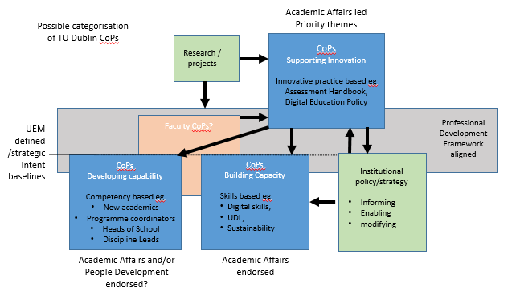
2024/25 Application
Applications are now sought from staff who wish to establish a new Community of Practice, to maintain or have an existing Community of Practice formally endorsed by Academic Affairs for the Academic Year 2024/25.
Successful applicants will be able to join the Community of Practice Facilitators group and receive support and training from Academic Affairs to enable the CoP’s further development. A small amount of funding is also available for those who do not have access to their own funding, to support the activities of their community of practice
All successful Communities of Practice will be required to submit mid-term and end of year reports and present at an annual Showcase.
Application Process
Applications should be submitted on the Community of Practice Support Application Form to Academic Affairs (CommunityofPractice@tudublin.ie) by 4th June 2024.

Criteria
Applications will be assessed by an Evaluation Panel using the below Marking Criteria. All applications submitted should have a core team of 2-4 facilitators that will take an active role in leading in the Community of Practice, with one facilitator nominated as lead for communications. A charter for the Community of Practice should be in place prior to the end of January 2025. The key activities for the Community of Practice, should be include a draft schedule of periodic meetings (approx. every 4 – 6 weeks) across the academic year and should include opportunities for members to share practice and resources.
Communities of Practice need to demonstrate how they are supporting the University to achieve its strategic objectives, education model principles or graduate attributes.

Criteria | Available Marks
Relevance to TU Dublin Strategy, UEM, Graduate Attributes | 150
Internal Membership Reach | 150
Potential Impact on Professional Teaching, Learning and Assessment Practice / Student Experience | 200
Evidence of Potential Sustainability and Future Growth: | 100
Relevant Experience of Applicants | 50
Total | 550

Applications will be ranked and prioritized using the Marking Scheme and where funding is requested, this will be allocated in a prioritized manner based on the budget available.

Outcome:
The outcome will be notified to lead facilitators by 18th June 2024
Successful Facilitators will be invited to a Community of Practice Facilitators Workshop. Facilitators will be expected to attend a launch event in September 2024 at which each Community of Practice will be expected to publish its proposed calendar of events for the Academic Year 2024/25. Communities of Practice will be expected to contribute to the Annual Showcase for Teaching and Learning.
Successful Community of Practice details will be hosted on the TU Dublin Academic Affairs Website.
Successful applicants will be required to submit a Mid-Term Report in February each year and a Final report in June 2025.
If you have any queries please contact Nicole O’Neill or Jen Harvey.

