Introducing the PICRAT model

The ‘PIC’ of PICRAT
This part of the model asks the question ‘What is the student’s relationship to the technology?’, to which there are three answers:
- Passive: Technology is used to deliver content but the students are not interacting with the technology or content e.g. watching a video or listening to a podcast
- Interactive: Technology is used to delivery content but the students must respond and engage with the content via technology e.g. taking online interactive quizzes or posting comments in a discussion board
- Creative: Students actively create something new using technology
This part of the model can also be mapped against Bloom’s taxonomy where passive learning activities support lower-level cognitive objectives like remembering; interactive activities support mid-level objectives like applying; and creative activities support higher-level objectives such as evaluating and creating.

The ‘RAT’ of PICRAT
This part of the model asks the question ‘How is the use of technology influencing the teacher’s existing practice?’, to which there are three answers:
- Replacement: The same instructional practices are carried out but are facilitated by technology
- Amplification: The integration of technology has increased the efficiency, productivity and effectiveness of the same instructional practice
- Transformation: The integration of technology has generated new instruction, learning or curricula

The PICRAT Matrix
The answers to these two questions “What is the student’s relationship to the technology?” and “How is the use of technology influencing the teacher’s existing practice?” are organized into a matrix. According to Kimmons et al, more active, more effective, and better-justified classroom technology practices generally occur at the top-right of the matrix (CT).
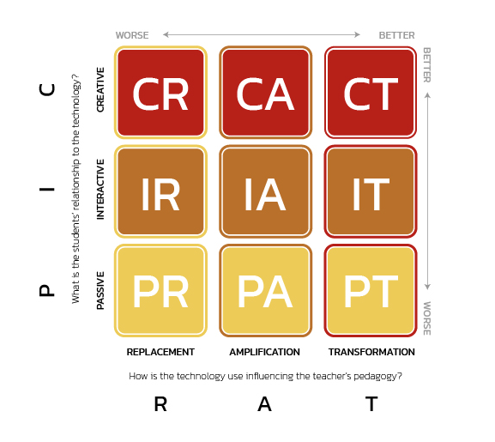
REF: https://edtechbooks.org/encyclopedia/picrat
The same sample activities used when introducing the SAMR model have been slotted into the PICRAT matrix below to help compare the models. All four examples can be classed as interactive. One activity is just a replacement of the original activity, but two of the activities amplify the practice, that is they increase the efficiency, productivity and effectiveness of the original activity. Only one of the sample activities is transformative in nature, encouraging the students to engage in several levels of Bloom’s taxonomy such as remembering, understanding, applying, analysing and evaluating. It does not, however, prompt the students to actively create something new using technology so hasn’t reached the most desirable point in the matrix, Creative Transformation.
Creative | CR | CI | CT
Interactive | IR  Instead of having students give a show of hands in class in response to a yes/no or multiple choice type question, the polling tool is used instead to gather this data. | IA  Instead of issuing a paper-based quiz, it is facilitated instead via the quiz function in the polling tool. Feedback explaining the correct answer is provided.  Instead of holding a class discussion where students raise their hands to offer their opinion, anonymous opinion type questions are posed instead via the polling tool. The responses will drive the discussion afterwards. | IT  Instead of teaching a topic and then using the polling tool to test students’ understanding, the polling tool is used instead to support a Question-Driven Instruction approach to learning which wouldn’t work without the kind of immediate feedback from your students that a student response system can provide.
Passive | PR | PA | PT
 | Replacement | Amplification | Transformation

Kimmons, R., Draper, D., & Backman, J. (2022). PICRAT: The PICRAT Technology Integration Model. EdTechnica: The Open Encyclopedia of Educational Technology. https://doi.org/10.59668/371.5895
Read, M. F. (2022). RAT: The RAT Technology Integration Model. EdTechnica: The Open Encyclopedia of Educational Technology. https://doi.org/10.59668/371.7485

