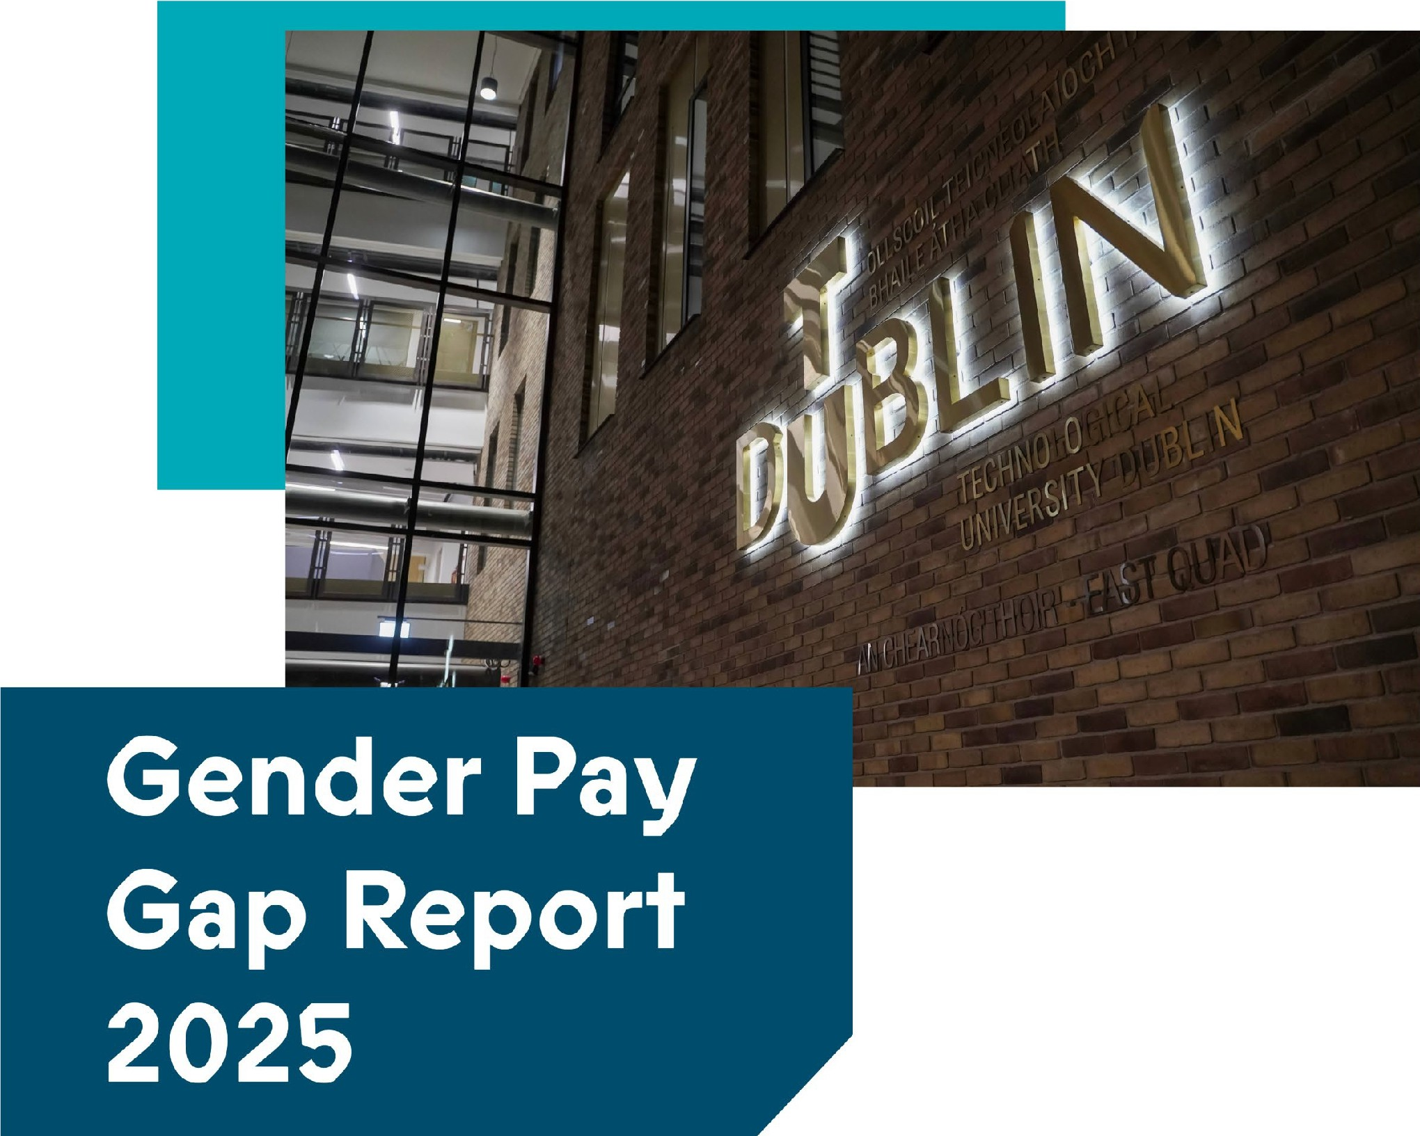

OLLSCOI� TEICNEOLAiOCHTA BHAILE ATHA CLIATH
T
DUBLIN
TECHNOLOGICAL
UNIVERSITYDUBLIN

FOREWORD, TU DUBLIN PRESIDENT
At TU Dublin, our values are the principles that guide our decisions, shape our culture, and define who we are; Excellence, Inclusion, Impact, and Respect. I am proud to lead an institution that recognises equality as a cornerstone of excellence. For us, Excellence means striving for the highest standards in fairness and transparency, including in how we address pay practices. Inclusion reminds us that diversity is our strength, and that every member of our community should feel a sense of belonging and opportunity. Through Impact, we commit to meaningful action, closing gaps, challenging barriers, and creating lasting change. And with Respect, we affirm the intrinsic value of every person, ensuring integrity and fairness in all we do.
This Gender Pay Gap Report is both a measure of where we stand and a call to accelerate progress. While we celebrate progress to date, we acknowledge the work ahead. Looking ahead, our priorities are clear. We will renew our Athena Swan Bronze Award, work to maintain and strengthen gender balance in decision-making roles, deepen our focus on intersectionality and continue to invest in professional development for women at every stage of their careers.
We are also building a workplace that recognises life’s realities. Enhanced maternity supports comprehensive guidance for managers, and initiatives for carers and those navigating menopause reflect our commitment to wellbeing and inclusion. These actions aim to create a culture where every stage of life and career is supported.
Gender equality is not just an aspiration for our University; it is embedded in our Strategic Plan and central to our equality and inclusion agenda. It is a privilege to serve as the first female President of TU Dublin, a milestone that speaks to the progress we have made and
the responsibility we share to keep moving forward.
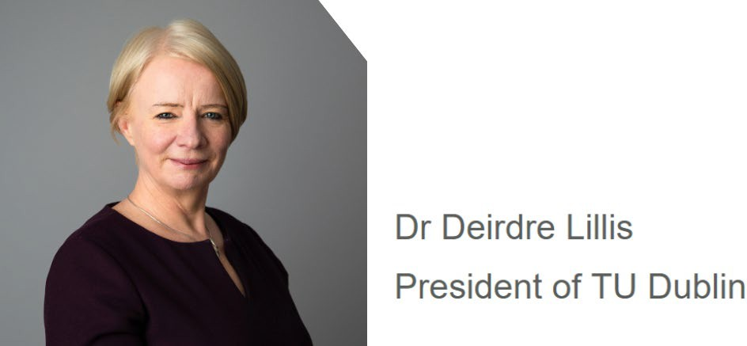
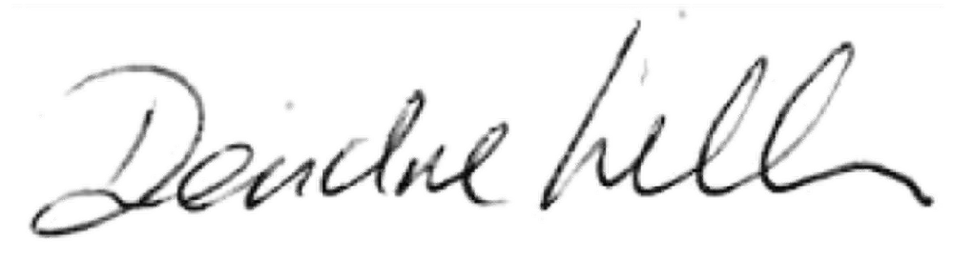

OVERVIEW OF GENDER PAY GAP

The gender pay analysis and profile is based on annualised pay effective 30 June 2025. All employees are aligned to pay grades which provide for equal pay for equal work irrespective of gender.
Our pay structures follow public sector guidelines, are fully transparent and are published on our website.
The total number of applicable employees at the snapshot date of 30 June 2025 was 3447 (females 1685; males 1762). All relevant employees were grouped into three pay cohorts for the purpose of analysis: full-time, part-time, and temporary. Each category is defined as follows:
- Full time: employees with a permanent or contract of definite duration employee status who work full time;
- Part time: employees with a permanent or contract of definite duration employee status who work part time;
- Temporary: employees with a specified purpose, fixed term or casual employee status who work full time or part time;

The employee headcount in each of these cohorts in 2025 was as follows:

Table 1: Employee Cohorts 2025
Cohorts | Female | Male
Full Time | 1093 | 1194
Part Time | 110 | 116
Temporary | 482 | 452
Total all cohorts | 1685 | 1762


TU Dublin does not make bonus or benefit-in-kind payments to employees.

As of the 2025 snapshot date, TU Dublin's overall average gender pay gap stands at 10.96% in favour of male employees, reflecting a 1.84% reduction compared to the 2024 figure of 12.8%. Among part-time employees, the gender pay gap is 2.42% in favour of males, a notable change from 9.89% reported in 2024. For temporary employees, the gap is 17.33% in favour of male employees, showing a slight decrease from the 2024 figure of 18.32%.

The Table 2 summarises the mean and median gender pay gaps for all employees, and for the part-time and temporary cohorts of employees.
Table 2: Gender Pay Gap 2025
Cohort | Mean Gender  Pay Gap (%) | Median Gender  Pay Gap (%)
All Employees | 10.96% | 17.58%
Full Time Employees | 8.83% | 19.72%
Part Time Employees | 2.42% | -4.69%
Temporary Employees | 17.33% | 29.56%

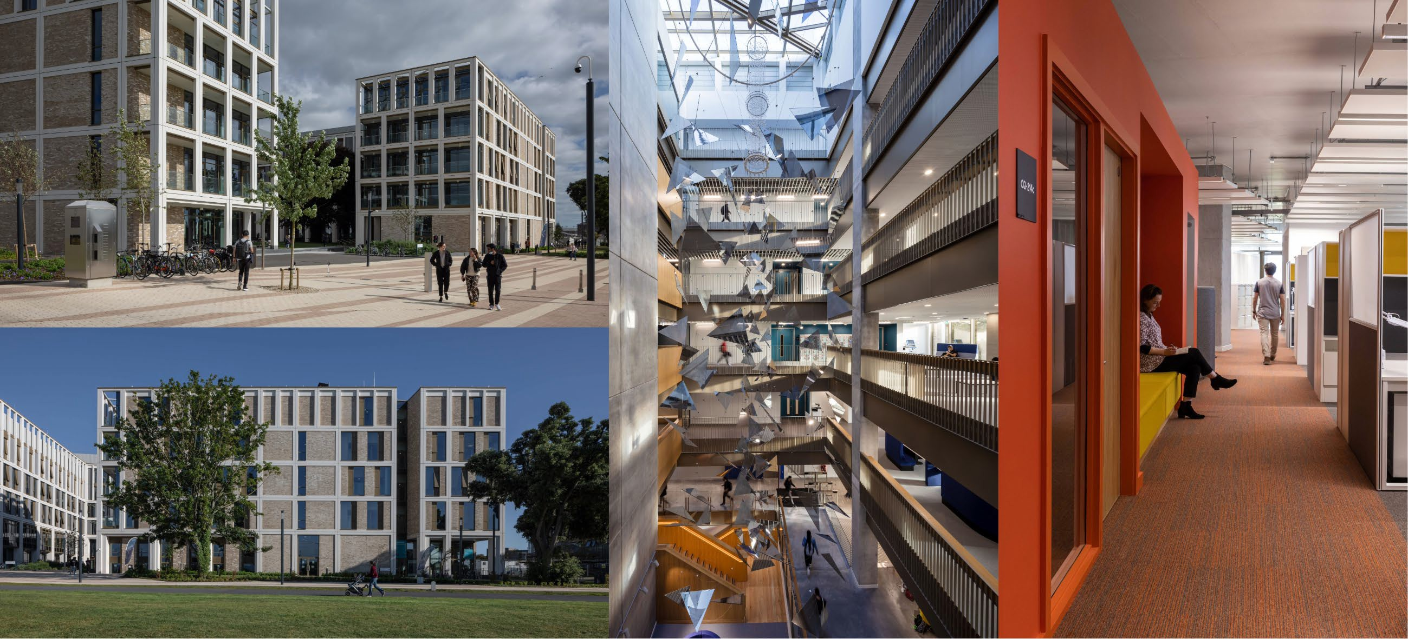

ANALYSIS

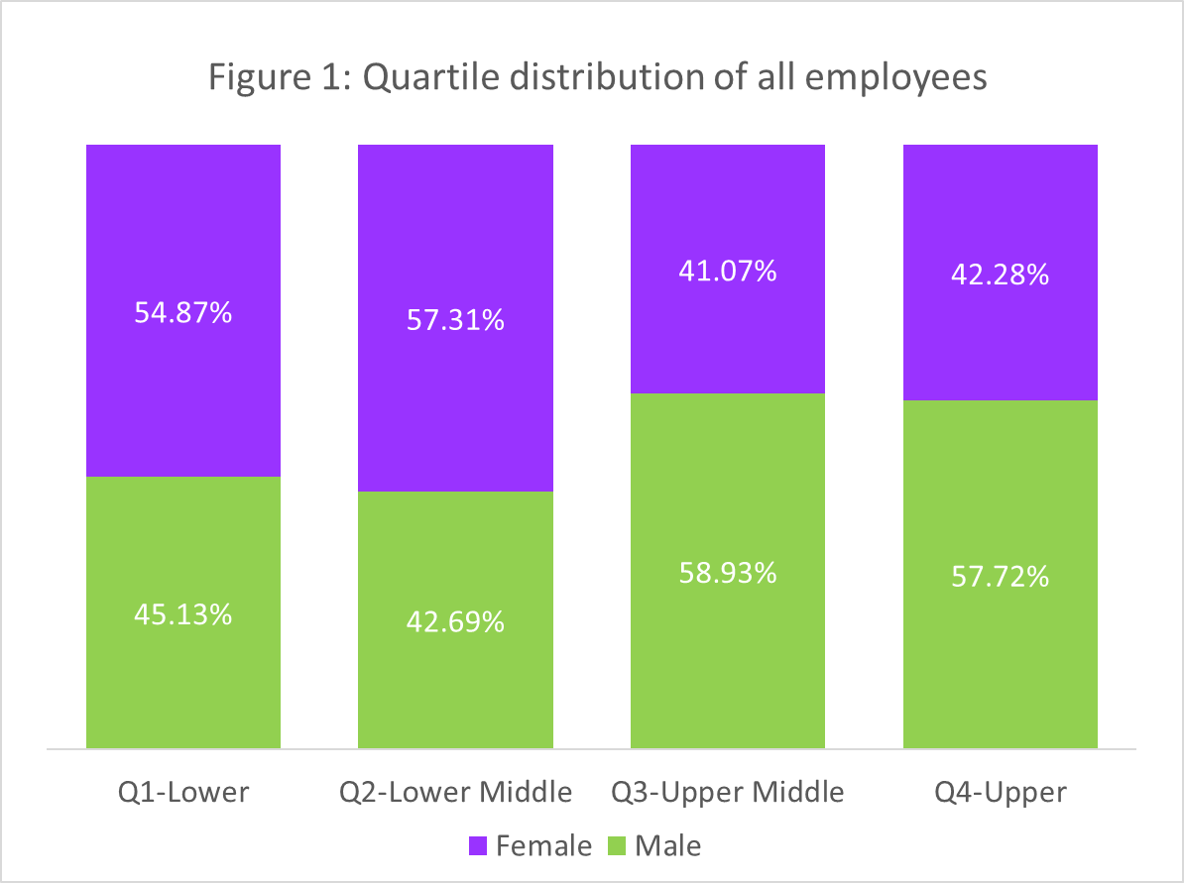
A quartile analysis of all employees (Figure 1) shows that female employees are predominant in the lower paid Quartiles 1 and 2, male employees are in the majority in the higher-salaried Quartiles 3 and 4. The proportion of females in the lower quartile reduced slightly in 2025 compared with 2024 by 2.79%. There was an increase in the proportion of females in the upper quartile by 5.18%, from 37.1% in 2024 to 42.28%
in 2025.

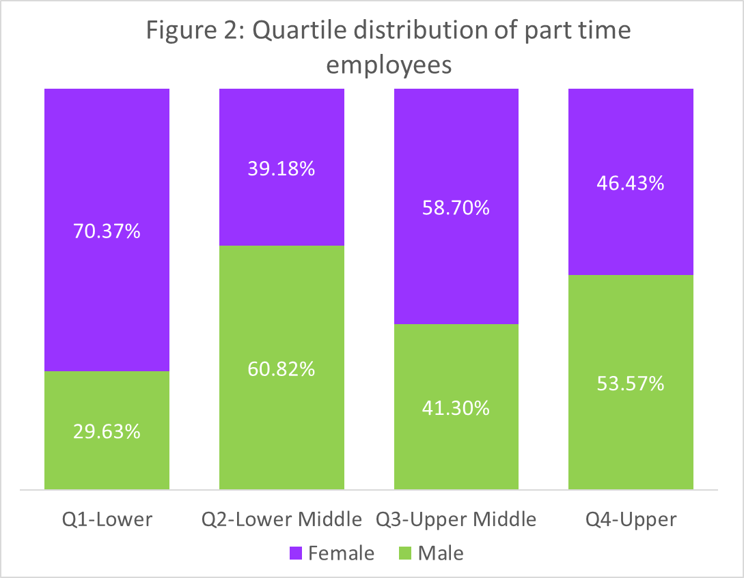
Part-time employees constitute a small proportion (6.56%) of all employees in TU Dublin. The gender pay gap for part-time staff is 2.42%, an improvement from 9.89% recorded in 2024. There has been a significant change in the quartile distribution of female part-time staff since 2024. Some of the change in the percentage of female staff in the quartile analysis is due to corrections in how hourly pay was
calculated, however this improvement in the gender pay gap figures is still welcome, In 2024, academic staff pay excluded the 8% holiday pay staff receive and used inconsistent weekly hours (35 for full-time, 16/18 for part-time), which distorted hourly rates. In 2025, holiday pay was correctly included, and all academic staff were assessed using a standard 35-hour week, revising hourly rates for some roles, particularly part-time and assistant lecturers, where women may be overrepresented. Additionally, underpayments in 2024 were corrected in 2025, increasing some salaries. These adjustments shifted staff between pay quartiles, affecting the gender distribution. The percentage of female part time employees in the lowest paid quartile

is 70.37% compared with 52.08% in 2024. There was an increase in female part-time employees in the top two quartiles; 58.7% in the 3rd quartile and 46.43% in the highest quartile compared with 46.81% in the 3rd quartile and 37.50% in the highest quartile in 2024. These changes in the highest two quartiles are likely to be driving the improvement in the gender pay gap for part-time staff.

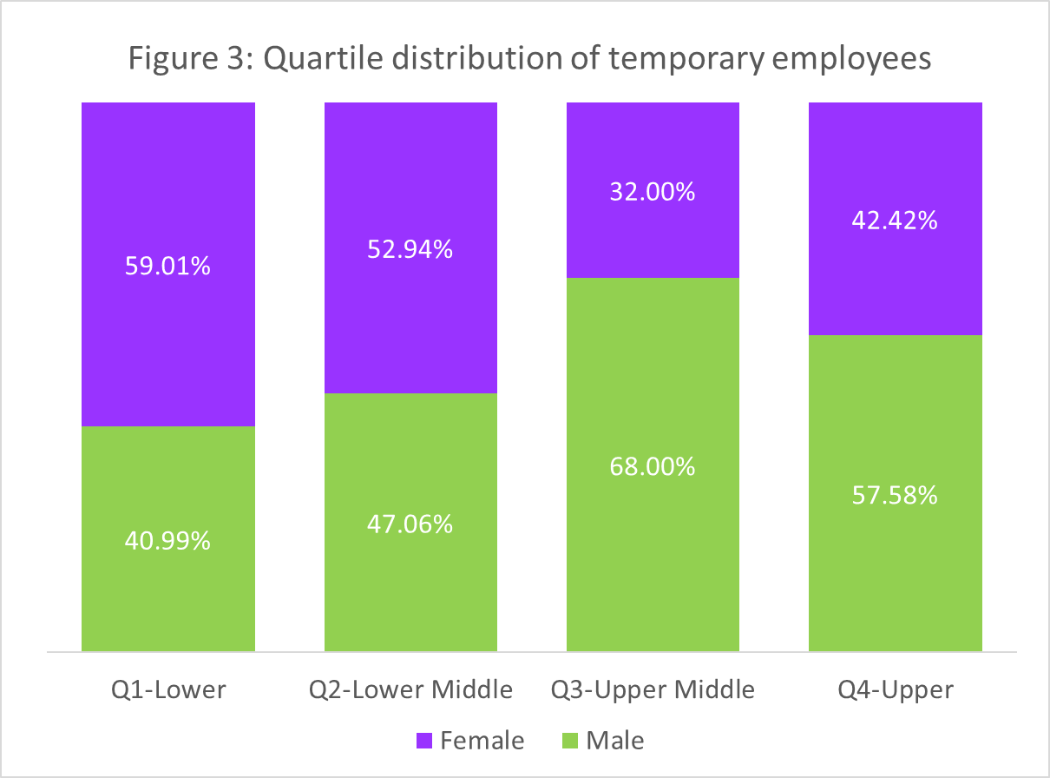
The largest pay gap of 17.33% is found among temporary employees, where females are concentrated in the two lower pay quartiles (Figure 3). Compared with the overall distribution illustrated in Figure 1, there is a higher proportion of female employees in this pay cohort’s quartile 1 and quartile 2. The pay gap for this cohort is slightly smaller than in 2024, when it was 18.32%. The reduction of female employees in quartile 1 from 67.53% in 2024 to 59.01% in 2025 explains this movement.


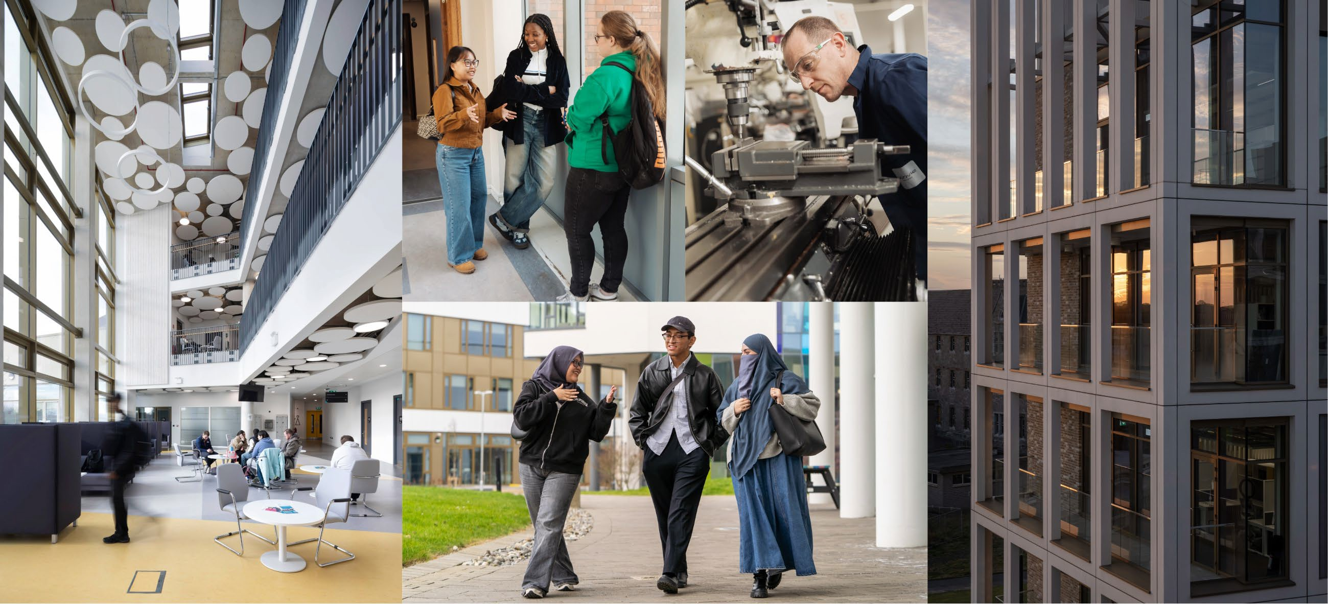

CAUSES OF THE GENDER PAY GAP

- The underlying factor for the University’s gender pay gap is the imbalance of men and women across job types and grades. Overall, female employees are in a majority in the two lower pay grades, while male employees comprise the majority in the two upper pay grades. This distribution is a key contributor to the gender pay gap.

- The gender pay gap among temporary employees (17.33%) contributes significantly to the overall gender pay gap. Females constitute 51.6% of temporary employees and are disproportionally concentrated in the two lower pay quartiles of this category

- The 2025 gender pay gap for academics stands at 2.32% in favour of males and is not a major driver of the overall gender pay gap.

- The gender pay gap for part-time employees is less pronounced than in the temporary employees category at 2.42%. However, the part-time employee cohort constitutes only 6.56% of all employees and is not a major driver of the overall gender pay gap.

VALUES AND CULTURE
An organisation's values should guide its actions, shape its culture, and provide a moral compass.
In 2023, TU Dublin reviewed and enhanced the University’s values, developing a clear and distinct meaning for each one:
- Excellence - in TU Dublin is about potential. We strive to do our best and bring the best out in others, aiming for high standards of service, good practice and commitment to continuous growth and improvement.
- Inclusion - in TU Dublin is about difference and diversity. We strive to foster an environment that encourages and celebrates this for individuals and groups, creating a safe space where people feel a sense of belonging and connection
- Impact - in TU Dublin is about positive change. We strive to invest our collective efforts into creating meaningful and lasting change in lives and actively seek opportunities to address the challenges facing the world.
Respect - in TU Dublin is about the intrinsic value of each person. We have deep regard for the feelings, needs and rights of others and we act with integrity.

Our actions towards gender equality are underpinned by our Values. At TU Dublin, our commitment to Excellence drives us to continuously improve and uphold the highest standards in equity and fairness, including in pay practices. Through Inclusion, we celebrate diversity and strive to create a workplace where all staff members feel valued and supported, ensuring that gender does not determine opportunity. Our focus on Impact motivates us to take meaningful action to address the gender pay gap, contributing to lasting change within our university and beyond. And with Respect, we honour the intrinsic worth of every person, ensuring that our policies and practices reflect integrity, fairness, and a deep regard for the rights of all staff.

ACTIONS
Gender equality remains an integral part of our Strategic Plan. It is also a core element of our equality and inclusion agenda, where the intersections of gender with race/ethnicity, age, disability, family status, sexuality and civil status inform our actions. TU Dublin holds an Athena Swan Bronze Award in recognition of its commitment to advancing gender equality and the University's plans to address systemic inequality. Below is a snapshot of some of the actions taking place in TU Dublin to enhance gender equality.
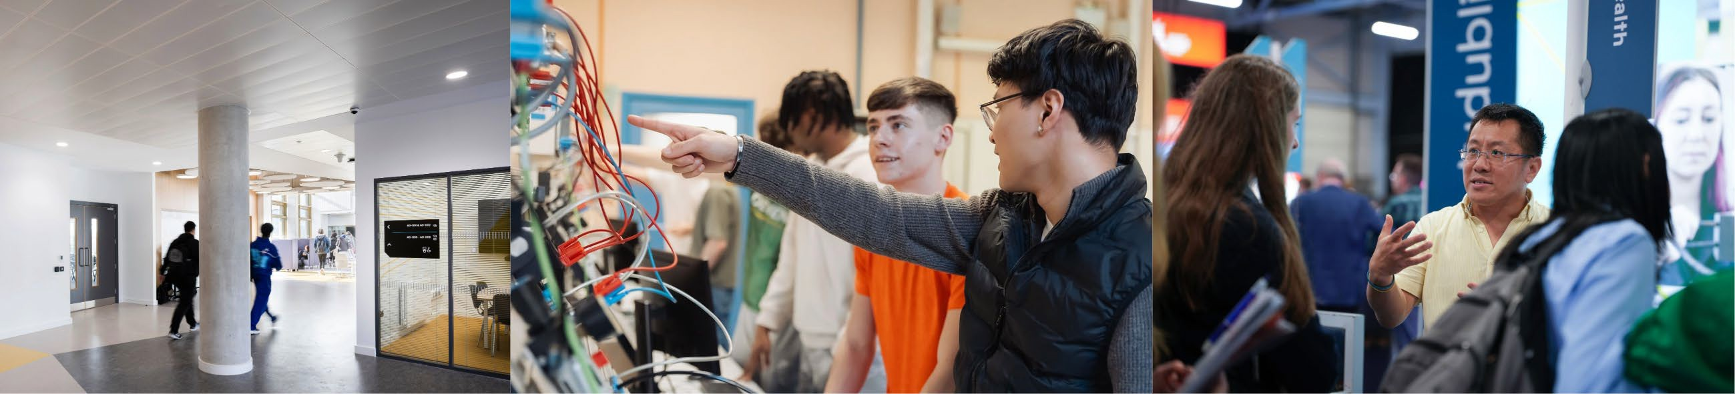

Learning, Development & Career Progression
TU Dublin continues to support gender equality through a range of targeted learning and development initiatives, with a strong focus on increasing female participation and leadership opportunities. Key actions and outcomes in 2024–2025 include:
- Fee Waiver & Support Schemes
  - Fee Waiver: Of 178 total applications, 87 were from women (49%).
  - Fee Support: Of 21 total applications, 13 were from women (62%).
- Leadership Development
  - KPMG Leadership Programme: 45 of the 77 applicants were women (58%), reflecting strong female engagement in leadership pathways.
  - Aurora Programme 2024: 13 women were approved to participate, with 3 receiving mentorship support to enhance their leadership journey.
- Mentoring Initiatives
  - Research Mentoring Programme:
    - 12 female researchers joined as mentees, representing 50% of all mentees.
    - 19 female researchers served as mentors, making up 61% of the mentor cohort, demonstrating strong female leadership in academic development.
- Management Skills Training

  - Essential Skills for Effective Management (2024): 13 of the 19 participants were women (68%), supporting the development of female talent in management roles.
- Women Leaders in Higher Education (WLHE) Network
  - Established in 2016, the WLHE Network continues to empower women across all roles, academic, technical, professional, and managerial, by providing a reflective space for personal and professional development, advancement, and peer support.


Inclusive Policies & Staff Wellbeing Maternity Supports
Enhanced supports for expectant parents have been developed, including new toolkits: ‘Maternity Leave Guidelines for Expectant Mothers’ and a ‘Maternity Checklists and Guidance for Managers’. These documents ensure that expectant mothers at TU Dublin have clear, accessible information on their rights, entitlements, and supports during pregnancy, maternity leave, and their return to work, which helps to reduce barriers women often face in the workplace. The document outlines legal entitlements in detail (such as paid and unpaid leave, breastfeeding breaks, and protections for premature births or illness) and emphasises wellbeing, safety, and emotional support, offering practical guidance such as risk assessments, Employee Assistance Services, and “keep in touch” planning. By combining policy clarity with holistic supports, the guide promotes a more inclusive and supportive work environment that recognises the diverse needs of mothers.
This Maternity Checklists and Guidance for Line Managers highlights the role of the University in ensuring a positive maternity experience, giving managers clear tools and empathetic guidance to ensure maternity leave is treated as a normal career stage rather than a disruption. It goes beyond legal compliance by addressing unconscious bias, encouraging open dialogue, and providing support around sensitive issues like pregnancy loss.

Support for Carers
Led by the Carers Task Group, this initiative takes a holistic approach to supporting staff with caregiving responsibilities. The group includes staff with lived experience and those involved in related projects across the university. Key actions include:
- Carers Support Website: A dedicated resource hub for staff and managers.
- Carers Employee Community Group: A peer-support network to share experiences and resources.
- Awareness Campaigns: University-wide efforts to raise visibility and understanding of carers’ needs.
- Policy and Training Development: Ongoing work to improve institutional policies, enhance manager engagement, and provide targeted training and supports.
- Experience Review: Working with relevant services to identify and improve processes and procedures to better support staff who have caregiving responsibilities.

The work of the Carers Task Group is ongoing, with new actions emerging from the Cross-University Carers Network, which seeks to align carer supports across the sector through policy, practice and research.


Menopause Support
The TU Dublin Menopause Task Group focuses on improving the experience of staff navigating menopause, with an emphasis on awareness, support, and policy change. Key actions include:
- Menopause Support Website: A centralised platform offering guidance and resources for staff and managers.
- Menopause Employee Community Group: A supportive space for sharing experiences and fostering peer connection.
- Awareness Campaigns: Initiatives to normalise conversations around menopause and promote understanding across the university.
- Policy and Training Enhancements: Continued efforts to embed menopause-inclusive practices into workplace culture.

- Experience Review: Working with relevant services to identify and improve processes and procedures to better support staff experiencing perimenopause and menopausal symptoms.
The Menopause Task Group’s work is ongoing, with a focus on embedding long-term, sustainable change.

Focus for 2026:

- Athena Swan: Following a self-assessment process conducted throughout 2025, submit an application to Advance HE to renew our Athena Swan Bronze Award.
- Gender Balance in Decision-Making: Continue to prioritise the greater inclusion of women in decision-making to maintain or increase our current minimum target of 40% gender balance in decision-making roles.
- Focus on Intersectionality: A focus on Intersectionality is required in gender pay gap reporting to explore how overlapping identities, such as race, disability and age, can compound pay disparities, revealing inequalities that may be obscured when gender is considered in isolation. TU Dublin is currently working on a campaign to improve disclosure of diversity characteristics to allow for this analysis in future gender pay gap reporting. In addition, we will continue to explore how gender and intersectionality shapes the employee experience within the University through the annual employee engagement survey and other staff listening channels.
- Professional Development: Support women at all stages of their careers to fully engage with the University’s professional development, leadership, and mentoring programmes.
- Financial Impacts: Monitor the impact of financial constraints on employee contract categories to identify any negative gender bias.
- EU Pay Transparency Directive: Prepare for the introduction of the EU Pay Transparency Directive in 2026, along with relevant Irish legislation, including assessing new data requirements under the Directive.
