Principles for Responsible Research and Innovation Practice

Introduction
The Technological Universities Act notes that the functions of the University are to support research and innovation, to pursue excellence in the conduct of that research and to support entrepreneurship, enterprise development and innovation in business, including knowledge transfer. Excellence in research and innovation is supported by a robust and supportive research culture, which minimises risks of misconduct.

Research culture is a term used to describe the combination of values, expectations and behaviours that influence how research and innovation is conducted, communicated, recognised and supported across all functions of the University. It emerges from the actions of individuals within the framework set out by the University. As research culture impacts the way in which an institution attributes value (e.g. during recruitment or promotion), it can create perverse incentives that influence behaviour, and create an environment in which poor conduct, poor dissemination practice and exploitation flourish.

A good research culture is one that prioritises honesty, inclusion and assesses those involved in research and innovation holistically, as outlined in Principle 9 below. Research misconduct is least likely to arise in a supportive research culture that encompasses all stages of the research and innovation lifecycle. The nine principles described below are key pillars that outline how we can as a community to support a responsible culture of research and innovation at TU Dublin.

Scope
These principles apply to all staff and students of TU Dublin, including those with positions as emeritus/emerita staff, visiting scholars and those with adjunct status who are engaged in research, in any domain of inquiry, and at all levels of the national framework for qualifications. This code also applies to those who support research and innovation across the University. Given the highly collaborative nature of modern research, this code will apply to TU Dublin researchers wherever research takes place.

Relationship with the Code of Conduct for Responsible Research and Innovation Practice
The principles outlined in this document represent a framework for responsible research and innovation practice, drawing from international and national best practice, and situating the principles within the context of TU Dublin. These are supported by a separate code of conduct, which presents these principles in a concise, portable operational format representing a first point of contact for those involved in research and innovation activities.

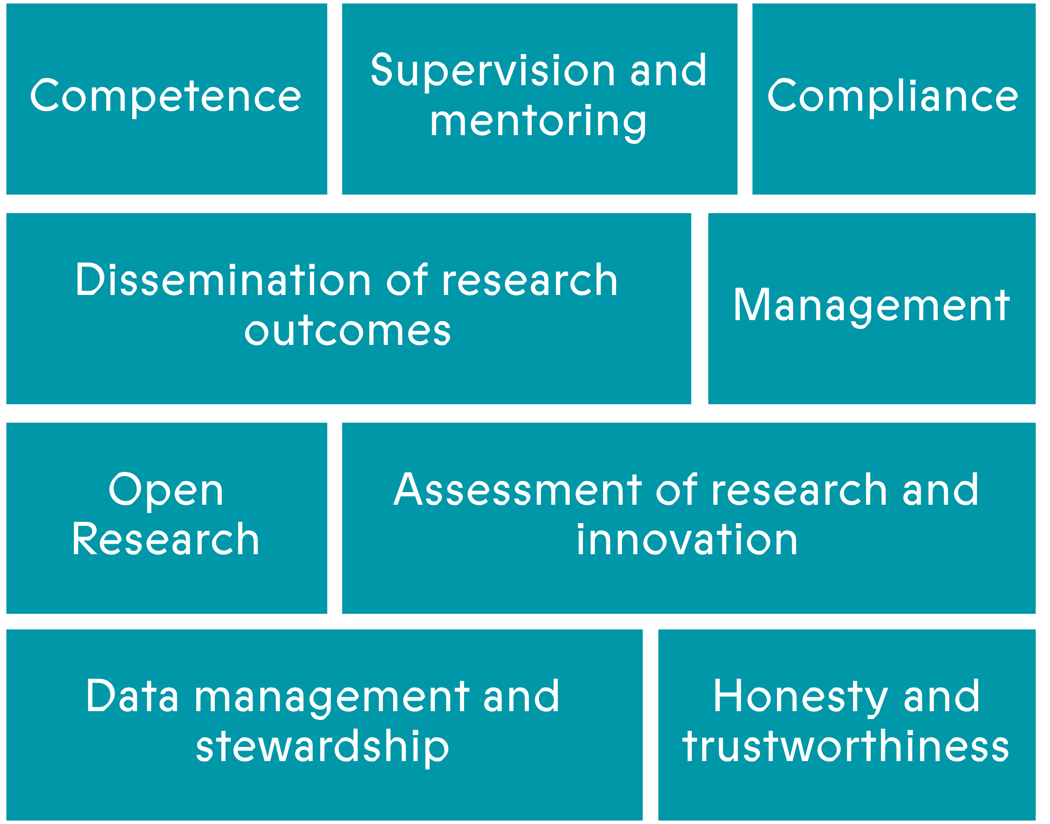
Principle 1: Competence
In the context of research and innovation, competence refers to the capacity of individuals or teams to conduct rigorous, ethical and methodologically sound work in a specific field. Competence therefore should be considered to include both domain expertise, methodological proficiency, self and team management, and supervision and mentoring of colleagues. It is a necessity to support the reliability and trustworthiness of research outputs and the overall research record.

All those engaged in research and innovation must be mindful of the limits of their own expertise and work within the scope of their own competence, in both primary research and innovation activities, preparation and dissemination or outputs, and contributions to the research community (e.g. grant review, peer review, media appearances).

Supervisors of graduate research students and postdoctoral researchers, and line managers of contract staff engaged in research and innovation activities must support the development of all those who report to them and ensure that they are competent to carry out the required activities. Identification of developmental needs for research staff is supported by the Researcher Career Development Framework.

Principle 2: Supervision and Mentoring
All those involved in research and innovation have a responsibility to foster the development of more junior colleagues and/or students, and to support their development holistically. This includes modelling responsible research and innovation practices, providing training, feedback and advice, and opening pathways for collaboration. Those in senior positions (e.g. Heads of School, Research Hub leads, Centre managers) have a particular responsibility to ensure those within their area are supported.

Supervisors of graduate research students are expected to be familiar with Ireland’s National Framework for Doctoral Education, the Irish Universities Quality Board/Quality and Qualifications Ireland ‘Good Practice Guide in the Organisation of PhD programmes in Irish Higher Education and related guides. All supervisors must obtain the University licence to supervise postgraduate students.

Supervisors and line managers of postdoctoral researchers and contract staff engaged in research and innovation activities must support the personal, technical and career development of all those who report to them. They are expected to facilitate this development by supporting them to adopt and actively engage with the Researcher Career Development Framework¹, including providing protected time for these developmental activities.

Principle 3: Compliance
Those engaged in research and innovation activities are expected to comply with all relevant regulations, legislation, University policies, financial procedures and codes, funder/sponsor requirements, and scientific and professional standards. They must also ensure that any relevant approvals, certification or training requirements (e.g. GDPR, ethics, AI, Research Security) are met before commencement of work. All those engaged in research and innovation activities must complete research integrity training and any required refresher training, as per the Research Integrity Policy.

Principle 4: Data management and stewardship
Appropriate management of data generated from research and innovation activities is essential to support reliability, reproducibility and trustworthiness of data arising from these activities. An authentic, traceable and auditable record of research data is the foundation of the primary research record and supports the protection of intellectual property. These records may be maintained electronically (using approved University platforms), as hardcopy, or any appropriate combination of these suitable to the discipline.

A data management plan (DMP) must be completed prior to the commencement of any activity. The DMP should describe how data will be collected, stored, shared and preserved throughout (and after) the lifecycle of the activity, and in the case of collaborative endeavours, clearly defined data ownership and responsibilities. This is an essential document to support all research and innovation activities and should be in place before the commencement of work. Sufficient time must be allocated to ensure that all records of work carried out are complete, accurate and up to date.

Principle 5: Management
Modern research and innovation activities are typically collaborative, across disciplines, institutions and jurisdictions. Management of these activities is a shared responsibility of all those involved. As the person who directs and oversees a given research and innovation activity, the principal investigator (PI) has primary responsibilities to ensure effective management of the overall work and involved personnel (including considerations related to export control and research security), budgetary control and adherence to funder conditions, report submission and ensuring whenever possible an ‘open first’ approach.

Beyond direct project responsibilities, the PI must foster a supportive research and innovation environment, support the wellbeing and professional development of all members of their teams, and contribute to the overall research and innovation culture of the University.

Principle 6: Open Research
Transparency in the conduct and reporting of research and innovation activities is essential for reliable, reproducible and trustworthy outputs. By default, primary data and final outputs should be open and accessible to whoever would like to engage with them, noting that there may be requirements to preserve intellectual property, meet ethical conditions or ensure compliance with sponsor requirements.

All those involved in research and innovation activities must embed open practices in their work, in accordance with TU Dublin commitment to being an ‘open first’ university. These practices are supported by well-designed data management structures, a FAIR compliant approach and the approach of ‘as open as possible, as closed as necessary’. When disseminating outputs of research and innovation activities, including datasets, an appropriate version of that output must be made available in a reputable open repository, accompanied by a suitable open public licence.

Intellectual property arising from research and innovation activities should be identified and protected at a sufficiently early stage to ensure compliance the University IP policy, the National IP Protocol and any funder/sponsor requirements.

Principle 7: Honesty and trustworthiness of research
Honesty must be a primary concern for all who are engaged in all research and innovation activities. It is the foundation of the overall research enterprise and essential to support trustworthy and ethical work. Without the ability to trust in veracity of these outputs, it is impossible to build on the results of others, build on their work, and advance knowledge and understanding. Plagiarism, falsification or fabrication represent core dishonest practices in research and innovation that represent serious research misconduct. There is a broad spectrum of other practices that are not consistent with good practices including, but not limited to, poor data management, misuse of statistics, exaggerating the importance of outputs, inappropriate use of generative AI and failure to meet ethical obligations. The requirement to prioritise honesty means that constraints or conflicts which arise due to external reasons (e.g. commercial, funding, collaborator, inducements) must be vigorously resisted.

All those engaged in research and innovation must ensure that honesty is the foundation of all parts of their day-to-day practice. A data management plan is a key tool. This requires attention across the full spectrum of activities, from planning and initiation of projects to data gathering, analysis and dissemination. The contribution of individuals to all outputs of research and innovation activities must be reported honestly in accordance with the University policy for authorship and publication. Individuals should be mindful of potential conflicts of interests which arise during research and innovation activities, including but not limited to grant review, thesis examinations, and collaborative activities.

Principle 8: Dissemination of research outputs
The University expects that those engaged in research and innovation ensure that the outputs of their activities are disseminated, both to the scholarly community and to wider society, in accordance with Principle 6: Open Research. All dissemination activities must be constistent with the principles set out in section 6 of the University Authorship and Publication Policy, including the criteria for claiming authorship of an output and the use of authorship agreements. Publishers and conference/event organisers with questionable and/or predatory practices must be avoided.

Principle 9: Assessment of Research and Innovation
The University is committed to responsible assessment of research and innovation in accordance with CoARA principles. CoARA defines a holistic approach to research assessment that is driven by qualitative evaluation, supported by careful use of quantitative indicators, and which recognises the full range of contributions to research and innovation, and outputs arising from these. In practice, assessment may be of a diversity of outputs and/or artefacts (e.g. publications, exhibitions, software, performances, datasets), individuals (e.g. thesis examination, recruitment, promotion), teams, centres or academic units, knowledge transfer, or funding proposals. PURE is the approved University research information management system to record such activities and outputs. All those involved in research and innovation activities are expected maintain an up-to-date record within PURE.

All those engaged in research and innovation activities must apply, whenever possible, the use of assessment approaches which are in accordance with CoARA principles and ensure that quantitative metrics are used judiciously and only to support qualitative approaches (e.g. there should not be a sole reliance on metrics such as H-index, field weighted citation impact). They must ensure that they only engage in assessment processes in which their own competence leads to an accurate and authentic assessment.

Unless sanctioned by the University or required as part of an external assessment process, AI-based tools must not be used to support assessment of research and innovation.

Document Approval
VERSION NUMBER | APPROVAL DATE | APPROVED BY (NAME AND ROLE)
V1.1 | 17th June 2026 | Governing Body

Available at: Researcher Career Development Framework
Link to be included here in relation to TU Dublin microsite where these are all available via URL.
Note that for export control is a legal obligation, and non-compliance may have a direct impact, via fines and/or imprisonment on individuals.
Policies available at: https://www.tudublin.ie/explore/policies-and-forms/research-and-innovation/
The PI is the individual primarily responsible for direction of the research and innovation activity, in charge of funding, cooperative agreements, or public service projects, contracts, or other sponsored projects and is the person in whose name the activity is registered in TU Dublin.
FAIR=Findable, Accessible, Interoperable, Reusable. See Open Research Unit for more details.
See TU Dublin IP Policy for more details.
See Table 1 (p12) National Policy Statement on Ensuring Research Integrity in Ireland
Note that for the purpose of the Authorship and Publication Policy, an author includes (but is not limited to) all creators, artists, performers, innovators, researchers and scholars who have solely, or as part of a collaborative effort, lead to a research, innovation or scholarship output.
Note that as per footnote 5 above, the meaning of authorship is as defined in the policy.
Please contact Research Services in the library for advice.
CoARA=Coalition for Advancing Research Assessment, see here for TU Dublin action plan
A Responsible Research Assessment Framework for TU Dublin is in development
PURE: pure.tudublin.ie

