Assembly Points

Aungier Street:

Whitefriar Street to Golden Lane

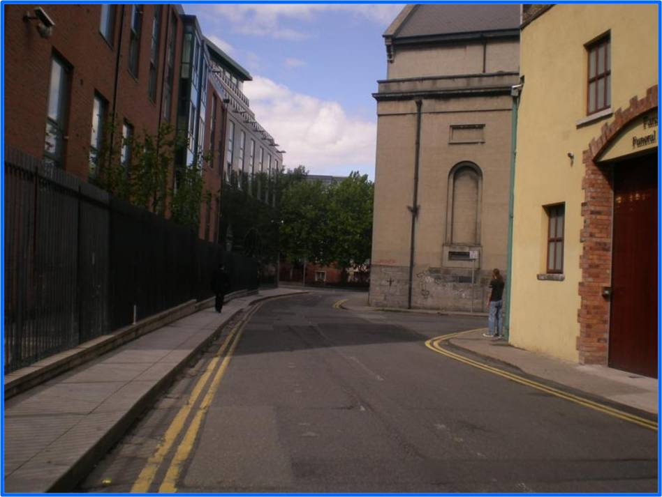
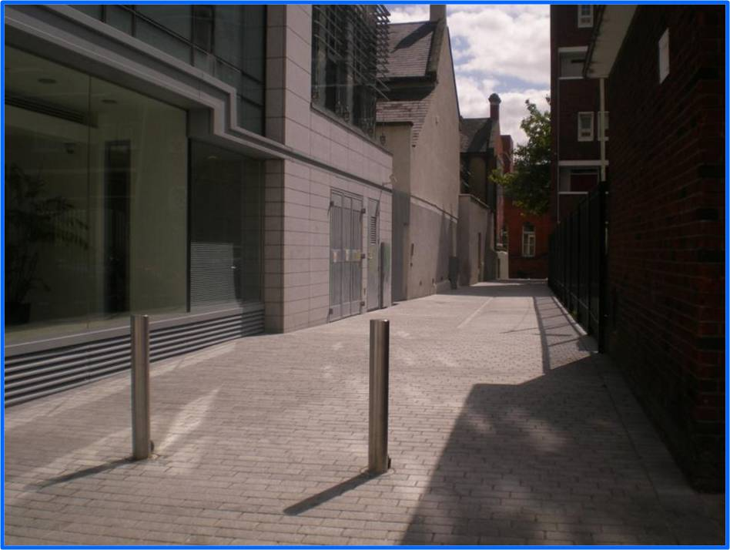

Bishops Street Lane to Kevin Street
____________________________________

Bolton Street Campus

Bolton Street Main building: Cineworld Cinema, Parnell Street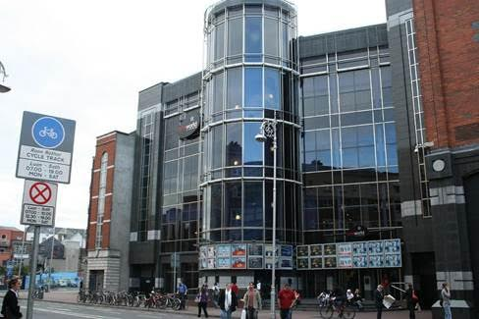
E-Block, 81 Capel Street :

Cineworld Cinema, Parnell Street

Beresford Street:

Stirrup Lane

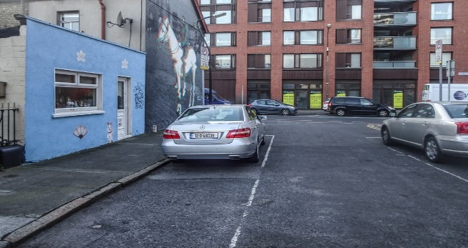

Linenhall: Henrietta Street

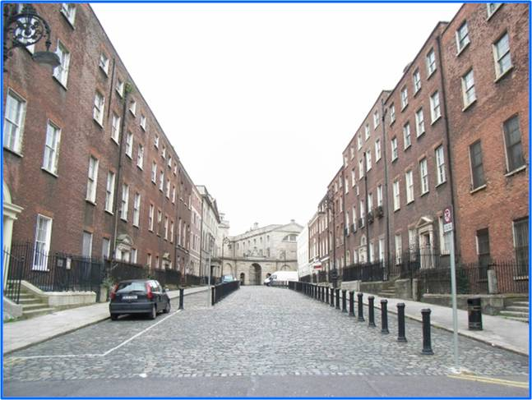

Grangegorman Campus

Assembly Point A

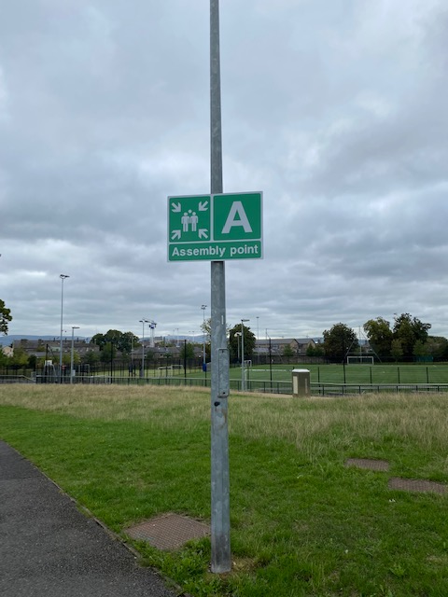
Rathdown House, Central Quad, Bradogue, Glassmanogue

Assembly Point B
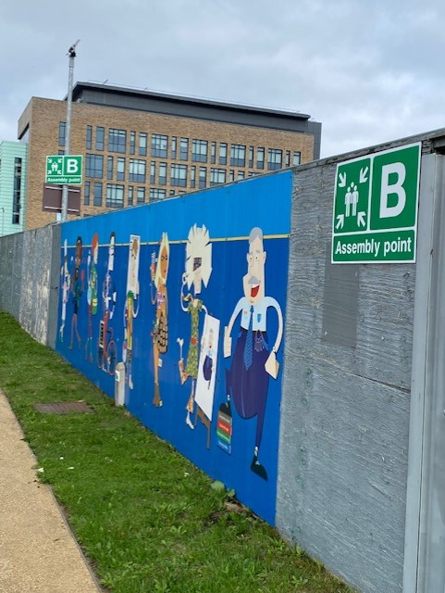

Clock Tower, Orchard House, Rathdown House, Greenway Hub, Central Quad

Assembly Point C
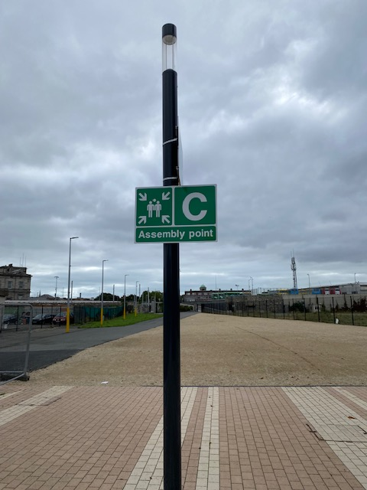

East Quad

Assembly Point D
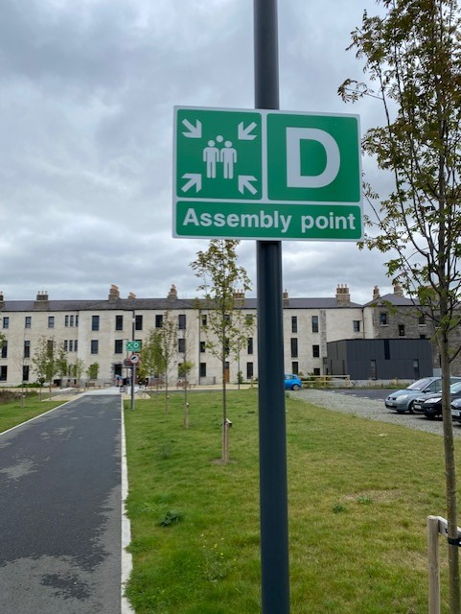

Lower House, East Quad

Park House
The assembly point is Annamoe Road to Annamoe Drive
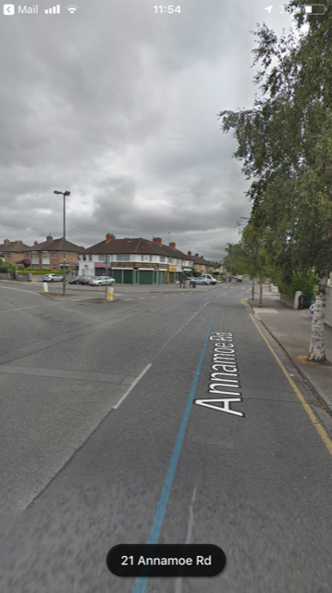
___________________________________

FOCAS Institute:

Camden Row



