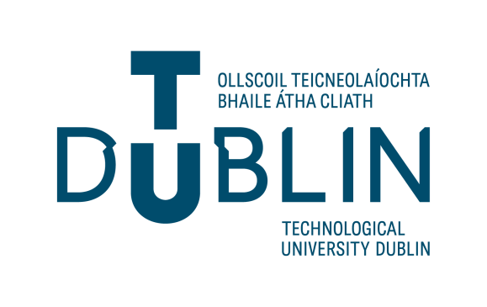

Guide to Garda Vetting and Completing

Application Form (NVB1)

- General Information

    - The Form must be completed in full using a ball point pen and BLOCK CAPITALS. Illegible and/or incomplete NVB1 Forms will be returned.
    - ONLY THE ORIGINAL signed NVB1 form will be accepted. Photocopies/scanned copies of the NVB1 form will be returned.
    - All applicants must present in person to TU Dublin Staff with PROOF of their identity and their original NVB1 form before submission of the NVB1 Form to the Talent Support Team (refer to Identity Document Validation Form).
    - Please contact your hiring manager or talentsupport@tudublin.ie to make a verification appointment.
    - Photo ID must be clear and all information must be visible and correspond with the information provided on the NVB1 form. Only original documents will be accepted for verification.
    - Vetting will be valid for up to a maximum of 3 years from the date of disclosure, after which you will be invited to engage in a re-vetting process.
    - Please see attached FAQ link to answer all questions you might have:
https://vetting.garda.ie/Help/FAQ

Personal Details

    - Insert details for each field, allowing one block letter/number per box. If you have no middle name, state N/A in the box.
    - For Date of Birth field, allow one digit per box e.g. 0 1 / 0 2 / 1 9 8 3
    - Please fill in your Email Address correctly and clearly, allowing one character/symbol per box, clearly showing the difference between letters/symbols/numbers, if the form is hand written. Letter O / number 0 or - _ .
    - When you submit your NVB1 form, this information is then sent to the National Vetting Bureau. The National Vetting Bureau will then issue you with an e-vetting invitation to the email address you provided on your NVB1 form in order for you to complete the vetting process.
    - Please check your spam/junk box if you have not received the Garda Vetting Invitation from the National Vetting Bureau within a week of submitting your NVB1 form.
    - You have 30 days in which to complete the Garda Vetting invitation process online before it expires. Otherwise, you will have to re-submit the NVB1 application form and documents again.
    - The role being vetted for must be clearly stated on the form, a brief comment explaining why vetting is required may be included on the advice of Talent Support.
    - The Current Home Address means the address you are now currently living at. Proof is
required.
    - DO NOT CANCEL THE ONLINE INVITATION: Otherwise you will have to re-submit the NVB1 form and verify your documents again.
    - The online form will ask if the role will involve working with children, if you are unsure of this answer contact talentsupport@tudublin.ie
    - The NVB will reject applications that do not provide postal codes for addresses lived in, in
England and Northern Ireland. Also, please note TU Dublin cannot assist with researching
past addresses an applicant lived in from birth–to date.
    - The address fields to be completed in full, including Eircode/Postcode. No abbreviations. EIRCODEs are available from http://www.eircode.ie/

    - When completing your address online please enter each address on a different line. Also, please note the NVB will reject applications that have a number of different addresses in the one year in different countries. e.g. 1980–1983 an address in France; 1981–1982 an address in Ireland.
    - Name of Organisation: The name of this organisation is Technological University Dublin.
    - TU Dublin cannot accept Garda Vetting from another organisation nor can we Garda Vet for another organisation.

3. Declaration of Application Example

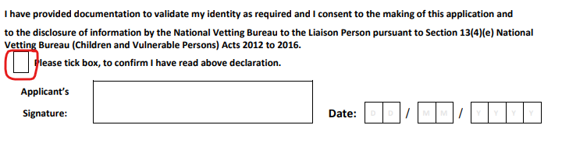

Please sign this form and put a current date in the DATE section provided.
PLEASE DO NOT PUT YOUR DATE OF BIRTH IN THIS FIELD.

Please submit queries on Garda Vetting to: talentsupport@TUDublin.ie

