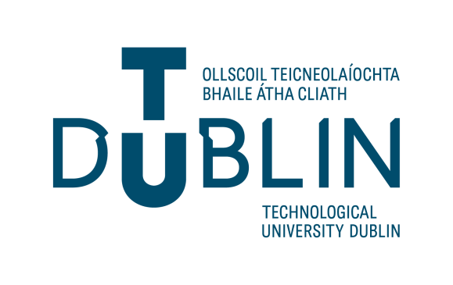

Guidelines for Staff on Garda Vetting and Verification of

Application Form (NVB1)

- General Information

    - If a role is listed on the approved register of relevant roles, then Garda Vetting must be completed. If the role is not listed on the approved list but the role will involve regular contact with children and/or vulnerable adults vetting is required.
    - Please refer to Schedule 1 of the National Vetting Bureau (Children and Vulnerable Persons) Acts 2012 to 2016, which outlines the specific categories of relevant work and activities that legally require vetting. If you are unsure, please contact Talent Support at talentsupport@tudublin.ie
    - The Form must be completed by the applicant in full using a ball point pen and BLOCK CAPITALS. Illegible and/or incomplete NVB1 Forms will be returned.
    - ONLY THE ORIGINAL signed NVB1 form will be accepted. Photocopies/scanned copies of the NVB1 form will be returned.
    - All applicants must present in person to TU Dublin Staff Grade VI and above or by a member of Talent Support Team with PROOF of their identity and their original NVB1 form before submission of the NVB1 Form to the Talent Support Team (refer to Identity Document Validation Form).
    - Photo ID must be clear and all information must be visible and correspond with the information provided on the NVB1 form. Only original documents are to be accepted for verification.
    - Verification involves completing the relevant section of the form stating that the person who you have met is the person who is to be vetted and that they are the same person whose photo ID you have witnessed.
    - Staff who have previously been vetted within the last 3 years will not require vetting. If they have been vetted more than 3 years ago, re vetting must be done.
    - NO PERSON IS TO BE ENGAGED IN ANY RELEVANT ROLE OR RECEIVE A CONTRACT PRIOR TO TALENT SUPPORT CONFIRMING THAT THEY HAVE COMPLETED THE VETTING PROCESS SUCCESSFULLY.

Please submit queries on Garda Vetting to: talentsupport@TUDublin.ie

