Career's Supports for Neurodiverse Students in TU Dublin

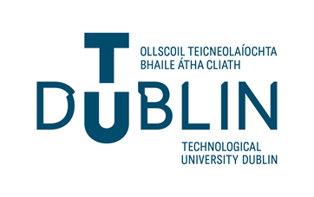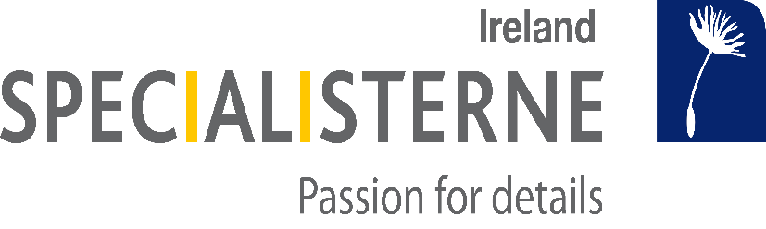

Specialisterne Ireland has partnered with Tu Dublin to provide a specialised recruitment service for neurodivergent individuals.

We provide our services free of charge to undergraduates and graduates who are:
Autistic (ASD), have ADHD, Dyslexia, Dyspraxia, or experience similar challenges.
If you require a placement as part of your course, our undergraduate programme is specifically
designed to help. We can support you with submitting applications and help you prepare for
internship interviews. Our programme runs from 6 to 8 weeks.
Our programme covers the following:
• Creating a professional CV and cover letter
• Interview skills – creating strong, honest, and impressive answers to typical interview
questions
• Mock interviews
• Identifying challenges and reasonable workplace accommodations
• Advising on disclosure in the workplace
Our goal is to work with you to identify what experiences and talents you already have. We can
then work with you to build your confidence to communicate effectively in an interview situation.
All undergraduates in our program can avail of our services upon graduation. We can work with you
to find employment and help connect you with our network of industry partners.

Youtube: https://youtu.be/Pc6tfBE1fXk

GDrive: https://drive.google.com/file/d/1zkQg5V32-1I35B9mM-ZA4zjTZfuOkW8K/view?usp=sharing
If you are a neurodivergent student and are interested in accessing our services, please Contact:
Specialisterne: admin@specialisterne.ie website: https://www.specialisterne.ie/
TU Dubin Careers: jennifer.mcconnell@tudublin.ie
TU Dublin Disability Service Webpage and Contacts: CLICK HERE

