Information for Host Families and Landlords
Thank you for your interest in TU Dublin student accommodation.
The TU Dublin StudentPad is our one-stop-shop for accommodation for students who are looking for a host family, a student accommodation hub or private rental accommodation (including house and apartment shares). Along with an accommodation search, the site offers advice on housing and locations and a message board.
All accommodation adverts are listed on this self-service site and students and landlords have 24/7 access to the site.
Registering your advert is easy, simply follow the guide below and create your advert. Make sure to indicate when the property is available, select suitable campuses as students filter by these when searching for accommodation on Studentpad and remember to upload photos of the room and your property.
Once you have created and saved your advert and it has been approved by us, your advert will be live and visible on our site.
TU Dublin Studentpad – Registration and Property & Advert Setup Guide
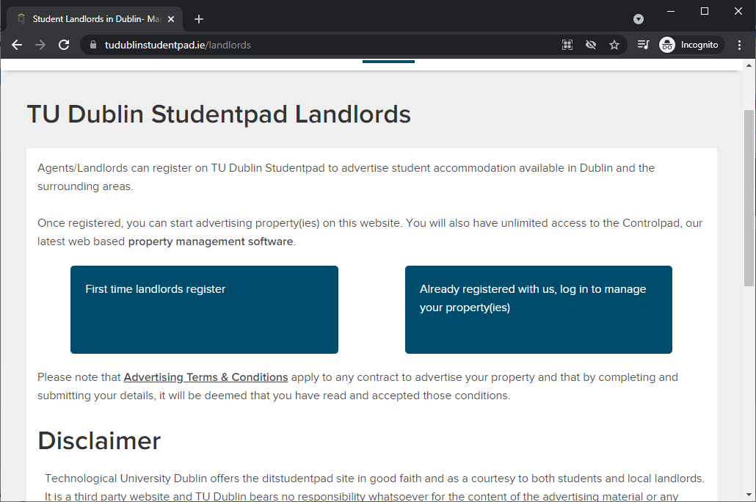
https://www.tudublinstudentpad.ie/landlords

Click ‘First time landlords register’.
On the following page click ‘Click here to register online’.

Review and Agree to the Terms and Conditions.
Review and Accept the Privacy Policy.
Enter your E-mail and password.
Enter your details: Name, address etc.
Finish Registration.
From here we will now set up your Property and an Advert for your property.
Property and advert setup must both be completed for your property to appear on the site.
A property with no adverts set up will not appear in any search results.

Property setup
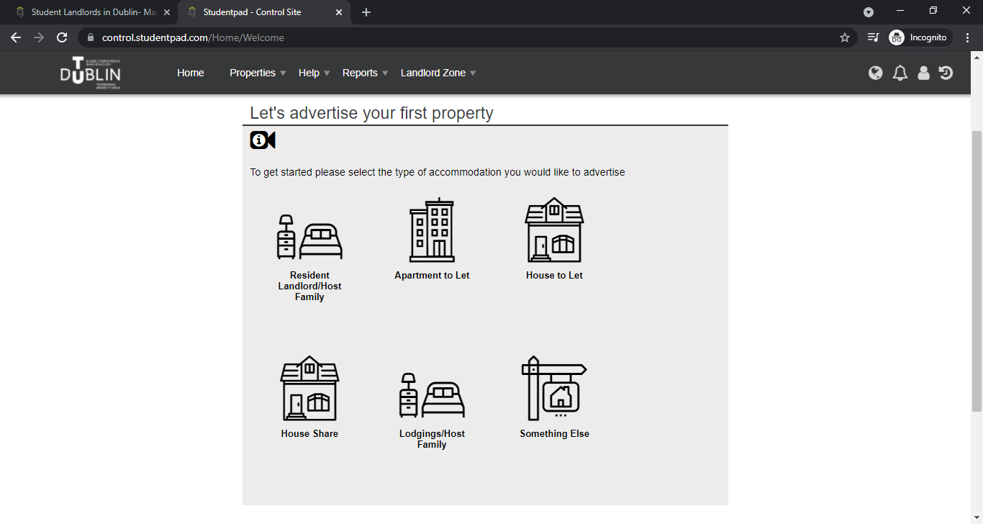
Select the kind of accommodation you are offering.
On the next page, enter your address or eircode and select yours from the dropdown list and click next.
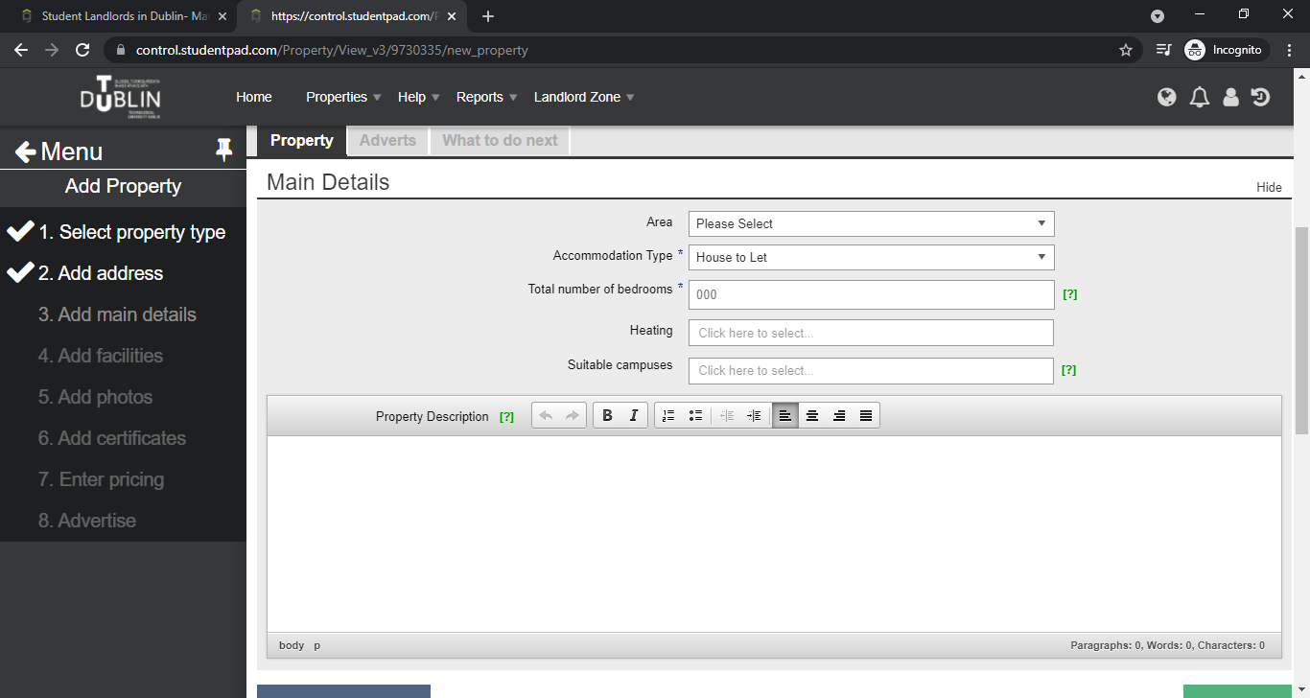

Fill in the basic property details and description and click Next.
Make sure to select suitable campuses as students filter by these when searching for accommodation on Studentpad.

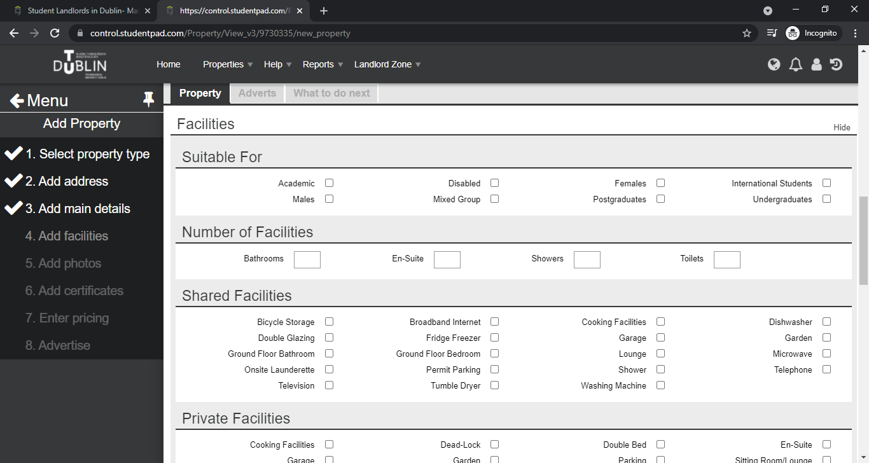
Complete the Facilities section, selecting all facilities you have available.

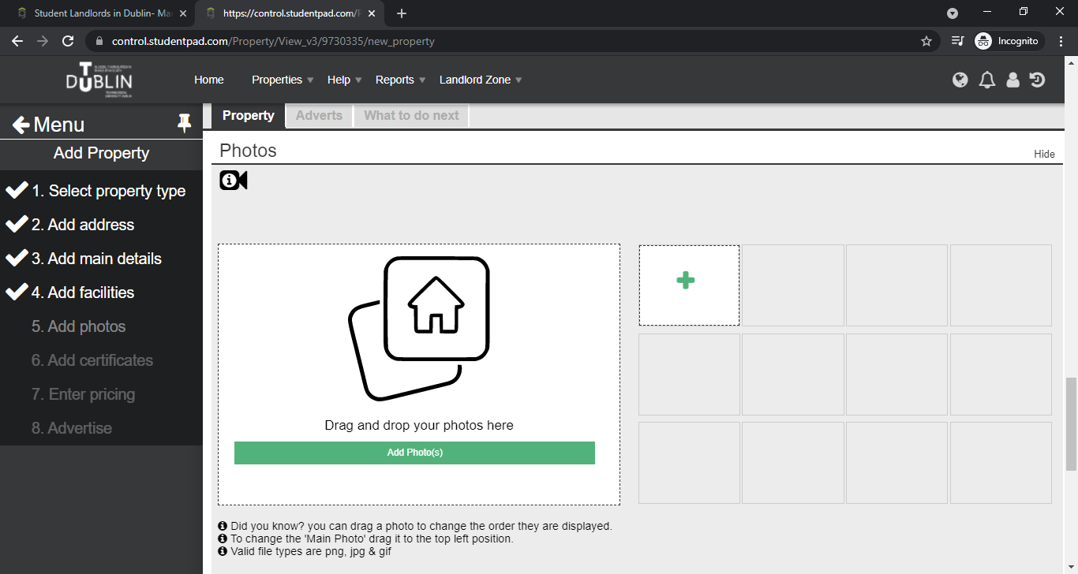
Add photos. You can add photos later if you do not have suitable photos or need help adding them.
You can email any photos you would like added to studentaccommodation@tudublin.ie if you are struggling to add them yourself.
You can click next, whether you have uploaded photos or not.
If you have a video tour of the property prepared, you can add it to your listing on the next step.
If not, click next.
Fill in your property’s BER rating and reference if you have one. If not, click Next.
This is the final step of Property setup. The next steps will set up your Advert.
Advert Setup
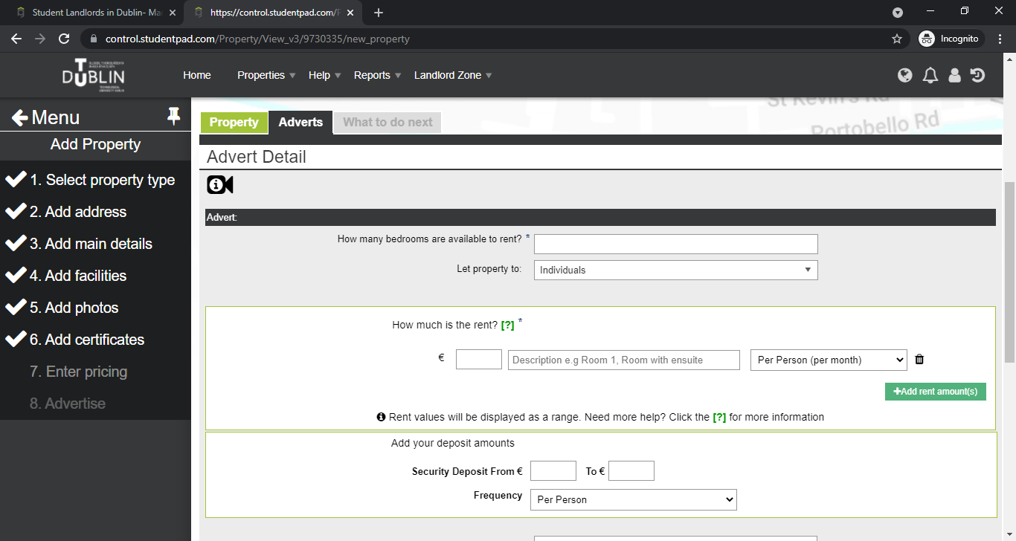
Fill in how many rooms are available and the rent for each room. You can add more lines using the ‘Add rent amount(s)’ button.
For Host Families we advise weekly rent amounts within the €100-€200 range depending on what is provided e.g. 5/7-night stay, breakfast/dinner included, bills included.
Generally speaking, international students seek accommodation for 7 days a week and for all the academic year and some of our home students may only need accommodation for 3 or 5 days only. Please bear this in mind when you answer the question what does your rent include?
Details such as these can be selected in the ‘What does your rent include?’ dropdown tick box menu.
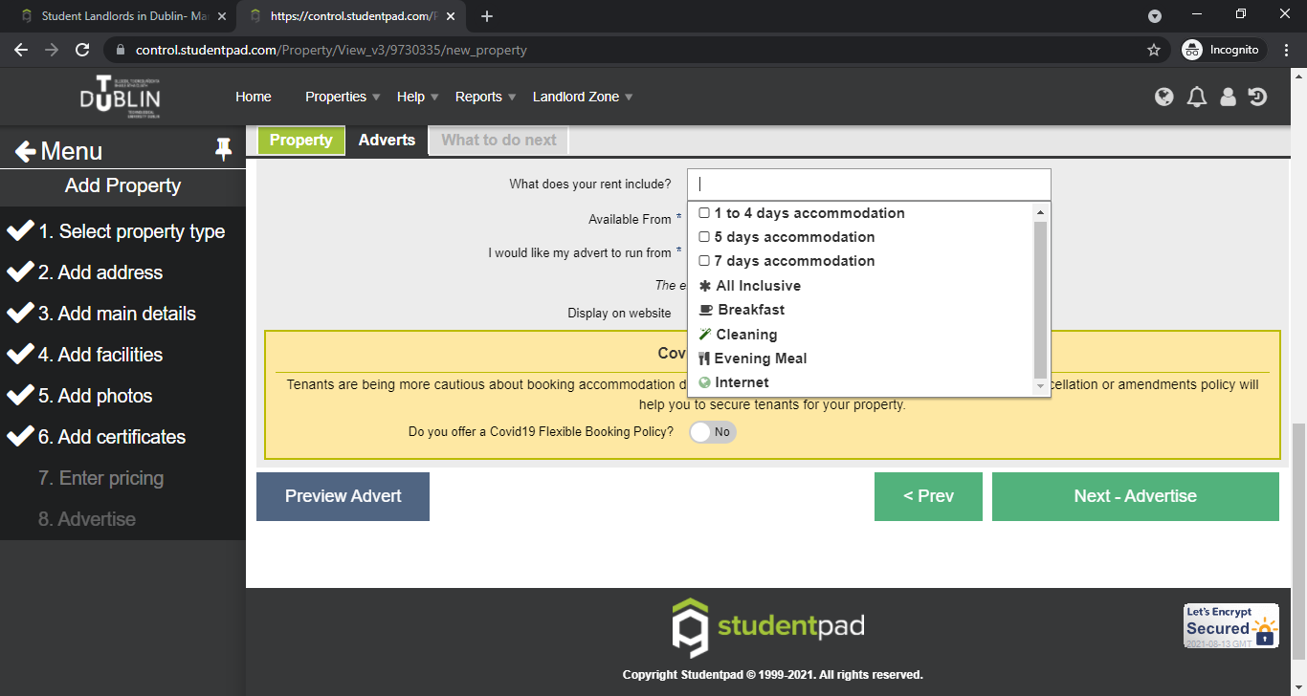
Enter the date the accommodation is available.
Enter date you would like this advert to go live on the site.
Review the Covid-19 Flexible Booking Policy.
Click next to complete Advert Setup.
Once approved your registration and property & advert setup is complete.

In future, to set up a new advert just log in and then from your Dashboard, click on 'Advertise a property'. On the next page you can choose between setting up a new property or putting up an ad for a property you have already set up on your account.
At the bottom of the page, click on the property you have set up and then click next. This will take you through placing an advert live on the site for the property you have set up.

In order to help you create an agreement, please read the sample agreement and Annex A document

Disclaimer
Technological University Dublin offers the TU Dublin StudenPad site in good faith and as a courtesy to both students and local landlords. It is a third-party website and TU Dublin bears no responsibility whatsoever for the content of the advertising material or any errors, omissions or inaccuracies contained therein. The information provided on the website is for information purposes only and should not be construed as a representation, recommendation or endorsement made on behalf of TU Dublin. TU Dublin have the right to vet adverts and remove adverts. The website content does not form part of any contractual agreement with TU Dublin and any lease or letting agreement entered into shall be between the student and the landlord only. TU Dublin cannot take responsibility or become involved in any disputes or letting issues between tenants and landlords.

