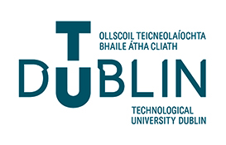Spring Semester
May 2024 Exam Timetable
Faculty of Arts and Humanities
School of Media

Important notice for all students:
Timetables are subject to change - revisit this site for updates
- Please ensure that you are in possession of a current photographic ID card
If not you should contact the Student Hub as soon as possible

- NBA = National Basketball Arena
- TU Dublin – Tallaght Campus

Bachelor of Arts (Honours) in Media Production and Digital Arts - YEAR 1
Timetable | Course Code | HAVAB_B - Year 1
DATE | DAY | SUBJECT | TIME | LOCATION
8th May | Wednesday | Film Style & Genre | 09:30 – 11:30 | NBA
16th May | Thursday | Media & Society | 15:30 – 17:30 | NBA

Bachelor of Arts (Honours) in Media Production and Digital Arts - YEAR 2
Timetable | Course Code | HAVAB_B - Year 2
DATE | DAY | SUBJECT | TIME | LOCATION
10th May | Friday | Media Politics | 15:30 – 17:30 | NBA

Bachelor of Arts (Honours) in Media Production and Digital Arts - YEAR 4
Timetable | Course Code | HAVAB_B - Year 4
DATE | DAY | SUBJECT | TIME | LOCATION
9th May | Thursday | Culture & Technology | 19:00 – 21:00 | NBA

Please ensure you go to the room/area allocated for your course code on your ID Card

