Describing how research active staff can comply with the university’s Open Access policy
Open Access Procedure

Table of Contents
1. Document Control Summary 2
2. Introduction / Context 2
3. Purpose 2
4. Scope 2
5. Definitions 2
6. Roles and Responsibilities 2
Outline the roles and responsibilities of those involved in enabling the procedure. Keep these to job roles rather than individuals where possible. 2
7. Procedure Details: 2
7.1 Procedure Overview 2
7.2 Procedure Details 2
7.3 Approval process 2
7.4 Change Process 2
8. Related Documents 2
9. Conclusions 2
10. Appendix 2
11. Document Management 2
11.1 Version Control 2
11.2 Document Approval 2
11.3 Document Ownership 2
11.4 Document Review 2
11.5 Document Storage 2
11.6 Document Classification 2

1. Document Control Summary

Area | Document Information
Author | Frances Madden
Owner | Vice-President Research & Innovation
Reference number
Version | 1
Status | Approved
Approved by | Vice-President Research & Innovation
Approval date | 27/03/2025
Next review date | 31/03/2028
Document Classification | Public

2. Introduction / Context
Technological University Dublin is committed to ensuring equitable access to scholarly information for all, irrespective of location or technological or financial means and preserving the intellectual output of the institution.

3. Purpose
This describes the process by which TU Dublin staff and students can meet their obligations under the Open Access Policy.

4. Scope
This procedure applies to all research publications produced by research personnel within TU Dublin, including full time staff, post-doctoral researchers, adjunct, emeritus/emerita, visiting and contract personnel and research students officially engaged in research work at the university and undertaking any research activity in TU Dublin’s name.
This procedure applies to all research publications produced in academic, educational, innovation, intellectual, research, scholarly, scientific, technical, or other similar, contexts in TU Dublin, including, but not limited to, journal articles, conference papers, books, book chapters and reports, while recognising that open access publication routes are more established within some research disciplines than others and for certain publication types.
This procedure does not apply to artistic, literary or other work not intended to constitute a research publication.

5. Definitions
Article Processing Charge
An article processing charge (APC) is a fee charged to authors by a publisher in exchange for publishing and hosting an open access article.
Author Accepted Manuscript (AAM)
The version of the manuscript that contains the final text, but not yet the typesetting and formatting from the publisher. For scholarly articles in journals, this is the text after changes in response to peer-review but before the publisher's typesetting and formatting has been applied. It may otherwise be known as the ‘author manuscript’, ‘final author version’ or ‘post-print’. For chapters, this is the version of the manuscript that has been agreed for publication.
CRIS
A current research information system (CRIS) is a system to store, manage and exchange data about research activity conducted by a research organisation. TU Dublin’s CRIS is PURE.
Diamond Open Access
The publisher provides immediate Open Access to the final published version of a publication on the publisher’s website, but there is no fee for publishing. Diamond open access publications are often supported by organisations, institutions, or other initiatives.
Gold Open Access
Gold open access means the version of record of a publication is made openly available on the journal or publisher’s website. Some OA journals require authors to pay an Article Processing Charge or similar fee. The article is usually made available under a Creative Commons licence which facilitates reuse.
Green Open Access
Green open access is also known as ‘self-archiving'. Authors deposit the author accepted manuscript of their publication in an institutional or subject repository in parallel with conventional publication. Publishers sometimes require an embargo period before the file can be made accessible to the public.
Hybrid Open Access
Hybrid open access refers to journals and books. A hybrid journal is a subscription journal in which some of the articles are open access, typically requiring the payment of a publication fee to the publisher to publish an article open access, in addition to the continued payment of subscriptions to access all other content. A hybrid book is a subscription title in which some chapters are open access, typically requiring the payment of a publication fee.
Institutional repository
An institutional open repository collects, preserves and disseminates the research outputs of an institution. TU Dublin’s repository is ARROW@TU Dublin.
Read-and-publish agreement
This is an agreement between the university and a publisher, where the University pays an annual fee that covers both the cost of subscription to the publisher’s journals (‘read’) and the cost of publishing Gold and Hybrid Open Access in these journals (‘publish’). This means that publishing Open Access in journals covered by such an agreement does not incur extra cost because these costs have already been paid for as part of the annual fee your library pays under the agreement. Read-and-publish agreements are negotiated by IReL on behalf of a consortium of Irish HEIs. The Irish Research e-Library (IReL) is a consortium of Irish research libraries.
Version of Record (VoR)
The published ‘version of record’ is usually a PDF that has undergone typesetting and has the publisher’s branding on it.

6. Roles and Responsibilities

Providing access to Preserving the scholarly record is part of the mission of the university’s institutional repository, ARROW@TU Dublin.

Individual staff and students are responsible for uploading an appropriate copy of each publication to the University’s systems to enable access to the publication via the institutional repository. Research staff should upload to PURE and research students should upload to the institutional repository, currently ARROW@TU Dublin.
Library Services Research Services are responsible for validating publications uploaded to PURE and posting publications uploaded to ARROW. This process ensures that all publication information is correct and that the appropriate version of the publication is made available via TU Dublin.

7. Procedure Details

7.1 Procedure Overview
This procedure describes how TU Dublin staff and students make their written work open access and how to meet the requirements of the open access policy through depositing in PURE or ARROW@TU Dublin.

7.2 Procedure Details
Following notification of acceptance for publication, researchers must make an appropriate version of this publication available. The procedure differs for staff and students:
- Research staff
- The staff member should confirm if the publication has been made open access via a publisher, i.e. through a read and publish agreement or through payment of an APC. If so, the version of record, i.e. PDF from the publisher’s website can be uploaded to PURE.
- If the publication is not published open access, i.e. with subscription access, the author’s accepted manuscript version must be uploaded to PURE.
- Full details of how to upload to publications to PURE are available here: https://tudublin.libguides.com/pureguide
- Library services staff will validate publications in PURE to ensure that the information provided is accurate and that the correct version of the output has been uploaded.
- Once a publication has been validated, the publication file and the information about the publication will be pushed to ARROW to be access from there. A link to the publication will be available on the staff member’s public research profile.
- Research students
- The student should confirm if the publication has been made open access via a publisher, i.e. through a read and publish agreement or through payment of an APC. If so, the version of record, i.e. PDF from the publisher’s website can be uploaded to ARROW.
- If the publication is not published open access, i.e. with subscription access, the author’s accepted manuscript version must be uploaded to ARROW.
- Full details of how to upload to publications to ARROW are available here: https://tudublin.libguides.com/Arrow/howtosubmit
- Library service staff will review and post items to ARROW so they are publicly accessible.
Any queries about versions of publications to be uploaded or whether a publication is subject to this policy should be addressed to the Library Services’ Research Services team in the first instance at library.researchservices@tudublin.ie.
Where the author has a strong view that a publication cannot be made open access immediately upon acceptance, this should be discussed with Library Services in the first instance. Formal permission for a postponement to making a publication open access can be given by the Vice-President for Research & Innovation.

7.3 Approval process
This procedure will be approved by the Research and Innovation Academy.

7.4 Change Process
This procedure will be updated in light of any system changes which results in a change to this procedure of compliance with the open access policy.

8. Related Documents
This procedure implements the university’s Open Access policy.
The university offers a range of support services to enable researchers to make their work open access. These include:
- the institutional open repository, currently ARROW@TU Dublin, providing a Green route to open access publishing
- the CRIS system, PURE
- access to IReL read and publish agreements,
- access to Diamond Open Access journals such as those published by TU Dublin
Other relevant resources include:
- National Action Plan for Open Research
- Plan S
- UNESCO Recommendations on Open Science
Related TU Dublin Policies
- Intellectual Property Policy
- Authorship and Publication Policy

9. Appendix
Decision tree to determine upload location and version requirement.
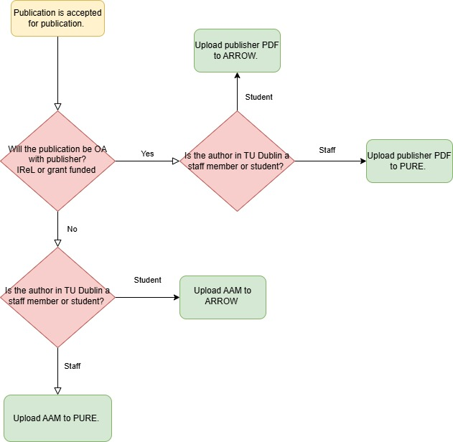

10 Document Management

10.1 Version Control
VERSION NUMBER | VERSION DESCRIPTION /  CHANGES MADE | AUTHOR | DATE
1 | Initial draft | Frances Madden | 24/02/2025

10.2 Document Approval
VERSION NUMBER | APPROVAL DATE | APPROVED BY (NAME AND ROLE)

10.3 Document Ownership
Vice President Research & Innovation.

10.4 Document Review
To be reviewed in conjunction with the policy at a frequency of every three years unless interim updates are required by system changes.

10.5 Document Storage
Policies & Procedures | Research & Innovation Policies, Procedures & Forms | TU Dublin

10.6 Document Classification
Detail the classification of the document so that users / readers know who to treat the information contained in the document.

