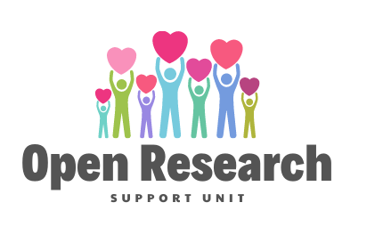
10 Things You Should Know About Open Licenses

- Copyright is restrictive, it tells you what not to do. A license is essentially permissive, it tells you what you can do. By using a license you (the creator) retain your copyright but can dictate how your material is to be used in certain ways under specific conditions. By contrast, putting something into the Public Domain means you give up all rights to the material so that infringement just cannot happen.

- A Public Domain Dedication such as Creative Commons CCO Public Domain Dedication, which is where material is put into the public domain does not include an any acknowledgement of you as the creator, since it is a waiver of all rights to the material. Only the owner or someone appointed on their behalf can waive rights. You need to think carefully about putting material into the public domain as anybody can then do whatever they like with it.

- Attribution mean that the person who grants the license must be given credit for the work when it is redistributed or reused.

- A copyleft requirement means any new works derived from the licensed one must be released under the same license as the original and only that one.

- A definitive Open License makes an item free to access, use, modify and share by anyone for any purpose . They do not have to even acknowledge you as the creator of the material. A license which prevents commercial use or the distribution of derived materials is not an open license in the truest sense but it is still on the spectrum of open. For example, Attribution and Not for Commercial Use are two conditions that TU Dublin will impose on materials that is in the TU Dublin Institutional Repository Arrow@TUDublin because we want the authors to be acknowledged and any commercial entities to come talk to us. But if those two conditions are met, the material can be reused and shared. It is always better to apply a license when making material available.

- Open Licenses are a set of conditions applied to the original work that give permission to anyone to make use of that work as long as they follow the conditions of the license. There is no fee involved and generally an open license will permit modification of the work with minimal restriction.

- Works that are made available without a license will generally be subject to the copyright law of the jurisdiction in which they are published. Copyright law gives exclusive rights to the creator and can be in place until the date of the author plus 70 years.

- Why use an open license? This lets people know what they can do with the material so it can be circulated freely gaining more exposure, people do not have to continually apply for permission, encourages others to improve and add value to the work and build on the work by creating new works based on or derived from the original.

- How do I apply a license? Get permission from any and all right holders to openly license the work, decide which open license suits you best and then put a link to the license on your work.
Creative Commons Licenses are the most widely used for straightforward material. They include all possible permutations ranging from public domain to non-commercial and no derivatives. These are considered open because they facilitate access but are not fully open because of the restrictions they place on reuse. CC BY-NC is not an open license but it grants broad permissions for use in research and teaching and for non-commercial activities. There are other licenses which are used for data such as Open Source (software source code) and Open Data Licenses (databases). Be aware that licensing software and databases can be very complex. A useful tool for choosing an open source license is choose a license.

- Embracing open research means putting as few restrictions as possible on your work. You also must remember that open licenses build on existing copyright law. Remember you cannot license materials that you do not own the rights to or that are not copyrightable in the first place.

