What is research impact?

This is where research moves outside the lab/studio/theatre to reach large numbers of people making a significant difference to their lives. The vaccine response to Covid-19 is a very good example of this. Society encountered a problem which science helped to alleviate by developing and providing vaccines. However, anything that involves people in the research process (citizen science), feeds into government policy or effects social change is research making an impact.
Essentially, assessing impact will be about exploring who might potentially benefit from the research and examining how the methods of dissemination of the findings can increase the number of potential beneficiaries of the research. A more formal definition will describe research impact as the demonstrable contribution that research makes to society and the economy. By engaging with dissemination, the researcher can acquire feedback that may help to shape their strategy and methodology; maintain relevancy by ensuring that the research is meaningful and timely; assist in recruiting participants for surveys/focus groups and raise the profile of the researcher/research group
The SFI website provides useful and practical information on research impact
Professor Mark Reed a researcher on research impact has described it “as what the good researchers do in the world.” Fast Track Impact is a very good resource for understanding impact and how to make an impact statement. Other useful tools include ImpactStory and kudos.

How does research create an impact?
As the word cloud above demonstrates, it is not simply a matter of assessing how much influence particular people, ideas, products or organisations have on others or the ways in which that influence happens. When thinking about impact the researcher should:
- identify potential users and stakeholders,
- articulate a clear understanding of the context and needs of users,
- consider ways for the research to impact on these needs and
- think about existing engagement with relevant end users.
In this context, it should be remembered that research-led teaching is a measure of impact and this can be clearly assessed by the clarity of conclusions to aid learning and the provision of case studies and examples.
Engaging with impact means that it becomes the responsibility of the researcher to ensure the maximum visibility of their research using a variety of methods to disseminate the findings of the research. This will be largely achieved through the published literature which will then result in bibliometrics being applied, but a researcher should also employ other means open to them such as Open Access Publishing (link to relevant section), the use of Social Media (link), Altmetrics (links) and Data Sharing (links).
Measuring research impact is challenging because the value that accrues from research may only manifest itself slowly over years and as such it is difficult to track and monitor. There is a need to find a balance between impact-orientated research and research that does not have immediate or direct impact.

Types of Research Impact
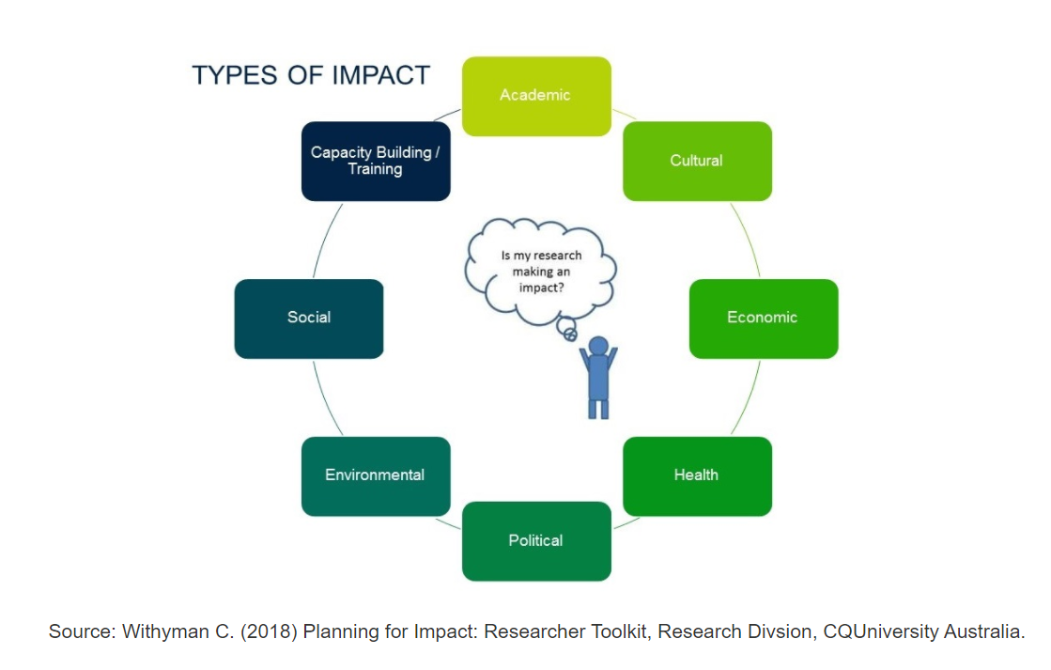

Academic Impact
Academic impact is the demonstrable contribution that research makes to academic advances. It includes such things as advances in understanding, methods, theory and application.

Cultural Impact
Cultural impact is when research contributes to the understanding of ideas, reality, values and beliefs. It is changes in the prevailing values, attitudes, beliefs, discourse and patterns of behaviour, whether explicit (e.g. codified in rules or law) or implicit (e.g. rules of thumb or accepted practices) in organisations, social groups or society that deliver benefits to the members of those groups or those they interact with.

Economic Impact
Economic impact can be defined as monetary benefits arising from research, either in terms of money saved, costs avoided or increases in turnover, profit, funding or benefits to groups of people or the environment measured in monetary terms.

Wellbeing impact
Impact in this area is when research leads to better outcomes for the health of individuals, social groups or public health. This can include saving lives and improving people’s quality of life, and wider benefits for the wellbeing of individuals or social groups. It includes both physical and social aspects such as emotional, psychological, economic wellbeing and measures of life satisfaction.

Policy impact
These impacts contribute to how policy makers act and how policies are developed. Recipients of this impact may include government, non-governmental organisations (NGOs), charities and public sector organisations and society, either as a whole or groups of individuals in society.

Environmental Impact
These impacts make a contribution to the management of the environment, such as natural resources, environmental pollution, climate and meteorology. The key beneficiaries are the natural and built environment with its ecosystem services, together with societies, individuals or groups.

Societal Impact
These are impacts where the beneficiaries include individuals or groups, communities or organisations whose quality of life, practices or activities have been influenced by the research. Public debate and the awareness, attitudes, education and understanding of the public have been enhanced by engaging them with research activities informed by research. Research may contribute significantly to community development and regeneration.

Training Impact
Research that leads to new or enhanced capacity (human resources, social capital and connectivity) through the development and improvement of training, curricula, pedagogical tools and qualifications that ultimately create benefits for individuals, groups, and organisations.

Pathway to Impact
Your pathway to impact links your research inputs and activities to your research outputs, outcomes and impact goals . Planning your impact pathway is important. When considering your pathway to impact, it is helpful to start at the end-point. What are your impact goals? Clear impact goals at the beginning of the project will influence the quality, magnitude and ability to claim and evidence the impact of your research.

